Pharmaceutical Healthcare in Rwanda
Name participant: Endriean Prajitno
Date of visit: 2 January – 23 January 2015
Email: e.prajitno@students.uu.nl

Table of content
Table of content 1
Foreword 1
Project background 1
Pharmaceutical education 3
Current situation 3
Some possible improvement and recommendations 3
Pharmaceutical field in the Rwandan healthcare 4
District Pharmacy 4
Hospital pharmacy 5
Role of insurance company within the pharmaceutical care 7
Insurance system in general 7
Final remarks and conclusions 8
Attachment: Observations and recommendations lab division at Kipharma 9

Foreword
Without the help of Farmacie Mondiaal Foundation (FM) and our Rwandan contact persons, this project would not have been successfully established.
I would like to thank the following persons who made this project possible, in particular Richard van Slobbe from FM for arranging the locations and retrieving Rwandan contact details. I also want to thank my travel partners Wietske Hemminga and Merel Philippart; Israel Bimpe, president of the Rwandan Pharmaceutical Student Association; Adeline Kazayire, hospital pharmacist at Ruhango Hospital; Eugene Kayitesi, hospital pharmacist at Kibogora Hospital; Serge Kamole, pharmacist at Kipharma; Giovanni Davite and Giancarlo Davite, directors of Kipharma.

Project background
This project is established under collaboration between Royal Dutch Pharmaceutical Student Association (K.N.P.S.V) and Farmacie Mondiaal Foundation (FM). A group of Dutch pharmacy students will visit Rwanda with the aim to obtain a deeper understanding on the pharmaceutical healthcare in an underdeveloped country. During a period of at least three weeks, different aspects of the pharmacy field will be explored and recommendations will be made in order to improve the pharmaceutical healthcare in Rwanda. FM financially supports the participants.

My visit in Rwanda was from 2 January until 23 January 2015. During my visit in Rwanda I have visited Ruhango Hospital, Kibogora Hospital, the Faculty of Pharmacy and its pharmaceutical student association in Huye and Kipharma in Kigali. The latter is a pharmaceutical company where I visited the production facility. A report of this visit can be found in the attachment separately.

The Republic of Rwanda has 12 million habitants (2013) living in a surface of 26,3 km² making it the densest country in Africa. At a certain point, all these people need access to pharmaceutical healthcare. But how is the pharmaceutical healthcare being regulated in Rwanda? Through which processes is the healthcare regulated? And in which way are regulatory bodies involved?

Pharmaceutical education

Current situation
The fundamentals of the pharmacists’ knowledge will be established at the faculty of pharmacy at the University of Huye (Butare) in Rwanda. Here, pharmacy training is carried out in four levels where each level consists of two semesters with an additional fifth year of internship. In the fifth year, the internees gain experience in hospital pharmacy (50%), community pharmacy (25%) and supply chain management (25%). In that same year they also have to start writing their thesis. After completing their thesis and internships, the student need to work a certain period in the pharmaceutical field in order to become a licensed pharmacist.
After spending a quick visit to the laboratory at the faculty, everything appears very new and clean. There are many analytical machines including HPLC’s and centrifuges, which were surprisingly in an almost brand new condition.

Some possible improvement and recommendations
The pharmacy students have to write their thesis in their fifth year. They have to choose a topic of own interest, which covers the pharmaceutical field. However, almost all students are restricted to write a literature-based thesis instead of a lab-based research thesis. This is due to the high costs of the analysis materials (reagents, buffers, HPLC columns, etc.). Unfortunately the university does not financially cover the usage of research materials, so the students end up paying for themselves. It is not known if the faculty has the budget available for these research materials.
The high costs of materials also lead to unoccupied labs during the curriculum. During the analytical courses there are often no analytical practicum included. In some cases when it is included, the students are limited by only attending demonstrative experiments in large groups of 20-30 students. All these students have to follow the lab teacher’s instructions carefully. Despite the costs of the materials, there is also only one lab teacher available for all the pharmacy students at the faculty.

When it comes to analytical skills, the students mainly study the theoretical part without really putting them into practice. A possible solution to overcome this problem is to teach students the essentials and basic principles of analysis. This can be achieved by setting up more simple analysis methods than HPLC in order to show the basics of chromatography. A suggestion is Thin Layer Chromatography (TLC). TLC can be done with tests based on colour-based substances and can be done within a simple setting.

Overall, there seems to be a lack of teachers at the faculty. At the university lab at Huye, there is only one lab teacher available. A possible idea is to transfer the knowledge from the teacher to the students and that the student will reproduce this acquired knowledge with their classmates in a teacher’s setting.
For example: the senior students can be trained and encouraged to lecture the junior students, which will be beneficial for both the teacher as well as the seniors.

In order to overcome the problem of the expensive research materials, a possible solution would be to search for similar materials, but then cheaper. Or ask for donations from companies who could supply their expired materials to the university for analytical purposes, so that the students are able to set up experiments at the lab.

Pharmaceutical field in the Rwandan healthcare
The pharmaceutical sector in Rwanda mainly consists of: district pharmacies, pharmaceutical wholesales, hospital pharmacies and community pharmacies.

District Pharmacy
Rwanda is divided into 30 districts and each district has its own district pharmacy (DP). In Rwanda we visited the District Pharmacy in Ruhango. In the Ruhango district there are 2 hospitals and 17 healthcare centres. The DP has one important main task: supplying drugs to the surrounding hospitals and healthcare centres in the designated district.

Besides supplying medicine stocks at hospitals and healthcare centres, the DP also has to maintain their own medicine stock, which is done by placing a monthly order at wholesalers and distributors. This process is regulated via licenses and certificates, which need to be approved by the Ministry of Health (MoH).
Rwanda does not have any national manufacturing sites, so all the medicines have to be imported, mostly via Indian wholesalers. Most of these imported medicines are generics and produced by Indian and Chinese manufactures.
The DPs need to be stocked with the essential medicine according to the National Essential Medicine List. This list is mainly based on the WHO’s essential medicine list.
When a certain medicine at the DP is out of stock, for example due to logistic problems at the wholesaler, the DP can always borrow the medicine from other nearby DPs. Depending on the availability of the employees at the DP, either the pharmacist or the nurse will collect the missing drugs at the other DPs. In some cases the DP needs to order the missing medicine at private pharmacies or even at international wholesalers.

Current struggles at the DP
As already mentioned, most of the generics are imported from Indian wholesalers. It appears that these medicines are not always of the best quality. During a random batch test, an Indian generic was analysed and it turned out that the dosage had a larger deviation than the reported deviation, despite the analysis (QP) documents. The analysis method was obtained through the European Pharmacopeia.
It might be a solution to perform more frequent sample tests in order to maintain the preserved quality of these imported medicines. An independent analysis board can test the samples on the contents and also the purity.
Luckily, there were more positive than negative aspects at the DP that we have visited. The stockroom is tidy, ordered and clean. The biologicals were stored in a fridge with the temperature being checked on a daily base. The administration data is mostly written down instead of inserted digital, but we saw employees with laptops processing the stocks. Employees write down most of their administrations, and despite the routine, mistakes do not occur frequently due to the double checks by colleagues. It is not known if mistakes are reported and analysed.

Hospital pharmacy
Each hospital pharmacy in Rwanda has at least one pharmacist. Only the few big hospitals can afford to employ two or even three pharmacists. The hospital pharmacist is responsible for all the provided and dispensed drugs in the pharmacy. Another important task is “store managing”. This mainly includes medicine logistics and maintaining the stock. Most of the time, the pharmacist is assisted by pharmaceutical employees, which are all eligible to dispense the drug, after documenting them with protocols.

Essential medicine
The hospital pharmacy must have all the essential medicine available in their stock. A requisition order at the DP needs to be placed one day in advance. Whilst for the private sector it takes at least 5 days due to approval of the Ministry of Health.

Committees
As a pharmacist, the delegation of the government decides which committee you have to be obligatory involved in e.g. drug and therapy committee, health and safety committee. These committees require a lot of time, thus it takes the pharmacist averagely 3 out of 5 working days being involved in these committees.

Rwandese Hospital Standard
There is a joint commission for accreditation established by the Ministry of Health. This commission set up hospital standards in order to maintain a qualitative healthcare standard in the Rwandese hospitals.
These standards consist of five risk areas:
- Leadership and Accountability
- Capable Workforce
- Safety Environment for Patient and Staff
- Clinical Care
- Quality Improvement

These risk areas are divided into 3 levels, where level 1 is the lowest and level 3 the highest achievable level standard. The Ruhango Hospital is a recently built hospital and currently has level 1 on all standards. The quality manager is responsible for increasing the quality and acquiring higher levels on these five standards.
Issues that are occurring at the DPs and hospital pharmacies
In general, there are two main issues that the Rwandan pharmacists are facing: administrative work and the medicine stockouts. The administration is, to say the least, a struggle for the pharmacist. This is mainly because there are two separate administration systems in the pharmacy with a different format: there is a dispensing system and a stock system. The MoH obliges the dispensing system for insurance declarations purposes and the stock system – which can only be accessed online after logging in – is required for the administration at the DP. In other words, this results in that the pharmacist has to enter the same administration in two different programs doubling up the administrative work.
Also, a big part of the administration is written on paper and has to be inserted digitally again later on. And on top of that there is a lack of a stable digital infrastructure. For example, there is no wired Internet connection, so Internet access is mainly obtained via a wireless (slow) connection through a USB stick.
All together, both systems require a good digital infrastructure with a stable and fast Internet connection in order to log in into the dispensing system. Due to a lack of a good digital infrastructure, especially in rural areas, it is difficult to work smooth and efficiently.

Secondly, another main occurring issue is the stockouts at the district pharmacies. This leads to a poor medicine flow resulting in certain medicine stockouts at hospital pharmacies and healthcare centres. The stockouts are mainly due to the poor cash flow between the insurance companies and the pharmacies (district + hospital). The pharmacy receives money from the insurance companies for each dispensed drug. However, the pharmacy receives this declared money after several months and in the worst cases it can be delayed up to 6 months.

Also, the hospital pharmacist is obliged to participate in many committees, mostly two or more and these require a lot of time. Together with their stock management, it takes up to 5 days a week. It is a pity to see that the pharmacists do not have enough time available to spend on clinical cases and have discussions with the specialist/doctors. Recruiting more (pharmaceutical) employees is not possible due to financial restrictions.

According to one of the hospital pharmacists we spoke to, the pharmacist would like to spend more time on clinical cases and less on stock management. Ideally the pharmacist would like to be responsible for the whole pharmacy, being involved in more clinical issues and having some more interaction with the specialist/doctors. One of the pharmacists told me: “The roots of this problem are at the MoH. The MoH doesn’t understand the role of the pharmacist and sees this profession mainly as a store manager instead of a clinician. At the university, the pharmacy student is focused on clinical practice, but in reality the pharmacist is a store manager and has almost none clinical influence.”

It would be more efficient to implement one central administration system together with a good digital infrastructure in order to reduce the time and the amount of administrative work at stock management. This will lead to more available time to be spend on clinical issues. Also for data sharing within a certain (hospital) network, a faster Internet connection would be beneficial to improve the work efficiency.

Role of insurance company within the pharmaceutical care

Insurance system in general
The Ministry of Health of Rwanda has embarked on a program to ensure all Rwandans have access to affordable healthcare through health insurance schemes. This includes the community based health insurance scheme or “Mutuelle de Santé”, government employees insurance and private insurance. The Mutuelle insurance payments are based on people’s ability to pay, making health access available for almost all Rwandans.
The identification of which household belongs to which category is usually based on a community participatory approach. The current classification comprises of 6 categories running from those in “abject poverty” to the “money rich”. Individuals from the poorest two categories are obliged to pay an annual contribution of 3.000 Rwandan Franc (RwF).
The government partly supports public insurance companies financially. The Mutuelle system is also partly financed by external aid, which covers insurance premiums for about 1.5 million vulnerable Rwandans. But Rwanda’s Mutuelle system does not cover all health costs for the poor people. Here below is an organogram regarding the structure of the Rwandan Health Insurance.

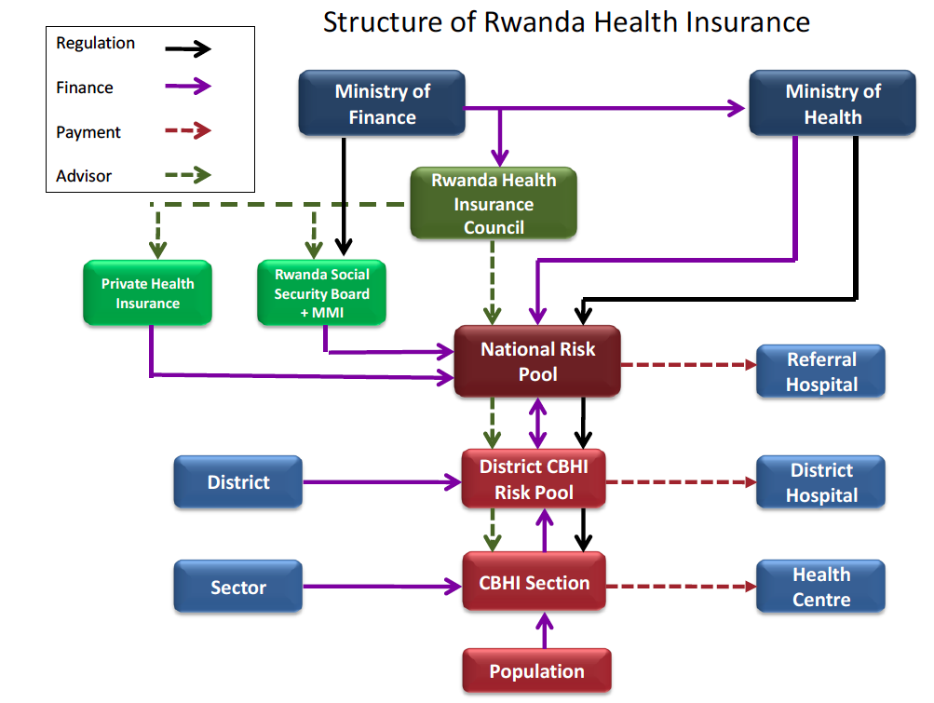
Source: Ministry of Health - Rwanda Insurance Health Policy 2010
The patients have to pay a tenth of the hospital bill and the (governmental) insurance company will pay the other 90%. However, some drugs are financed by the government e.g. HIV/AIDS or TB drugs and these are freely accessible for the patients.
The hospital as well as the district pharmacies receives their declared finances from the insurance companies. Due to this 10-90 ratio, there’s a financial gap slowly arising at the insurance companies, making them financially less stable and probably also having a negative cash flow. This results in delayed payments to the DPs and hospitals with an average of 2-3 months, leading to financial issues and therefore medicine stockouts at the DPs and hospital. A possible solution is that the premiums should slightly be modified where higher incomes pay more premiums on yearly base, in order to support the country with solidarity.

Final remarks and conclusions
It is not known if the faculty of pharmacy of Huye has the budget to cover the costs for research materials at the lab for the students. The university of Huye’s faculty of pharmacy should be contacted and considered if a higher budget could be made available for the laboratory and its materials. A donation of (expired) materials or financial donations are a creative, but less steady solution, to overcome this problem.

The two main issues that have to be solved at the hospitals are the stockouts and the doubled administration. The administration will save up much time when implementing one central system at the DPs and the government. The implementation of one central administration system should be requested within the regulatory bodies at the MoH. Improving the digital infrastructure will certainly improve the work efficiency and faster data access.
When comparing with other surrounding countries, Rwanda is doing a tremendous job with its healthcare system. It should not be forgotten that the majority of the Rwandan citizens have access to healthcare and this includes free access to TB and HIV/AIDS drugs. There are lots of potential and possibilities available within the Rwandan healthcare. The future looks bright and this also includes for the role of the pharmacist.

Attachment: Observations and recommendations lab division at Kipharma

Here below are observations and recommendations based on my visit at the lab division at Kipharma on January 20th and 21st, 2015.

Lab administrative worker (Miss Josephine and Miss Francine)
Josephine registers each new magisterial product in the system’s database. Of each product, the amount of active ingredients and pharmaceutical excipients are filled out in the database. In another logbook, the exact amount of the compounded product is registered into the system on a daily base.
As for Francine, she registers all the galenic-related preparations in the administration system.

Only dermatologic products are being compounded at the lab division. For both galenic and magisterial compounding, the pharmacist uses the U.S. Pharmacopoeia as a reference for the compounding method and the quantities. Also, every compounded product holds two labels: one is placed on the package of the product itself and another one is placed on the prescription sheet for administrative purposes.

Galenic compounding
Regarding the melting of the fatty excipient(s) for an emulsifying agent on a large scale; there was no thermometer accessible/available in order to measure the temperature of the melting substance. This can influence the quality (mainly the viscosity) of the product once it clots.¹
Also, there was no employee present to stir the melting substances. It is advisable to stir the paraffin during its melting process in order to create a homogenous substance.

Magisterial compounding
The workplace is clean and so are the tools that are being used for preparing the magisterial preparations. Here, wearing a cap and gloves are mandatory in order to prevent contaminated products.
An important focus point is the homogenous mixing of the magisterial products. Since all the observations are done by sight, it is difficult to see if the preparation is mixed homogenously. In order to overcome this problem, the substances should be added in a 1:1 ratio at each step.

An example: a 6% urea 200 gram ointment needs to be made:
Start with the lowest quantity, which in this case is 12 gram of urea. This one first needs to be mixed with 12 gram self-emulsifying agent. (Total mass is 24 gram now.) Mix this mixture until homogenous before adding another 24 gram of self-emulsifying agent. (Total mass is 48 gram now.) Add another 48 gram of self-emulsifying agent until all the ingredients are added to the mortar.

Another good thing that I’ve seen is that there are deadlines/schedules set, which are quite strict and it stimulates the productivity by setting deadlines. (e.g. 8am orders needs to be finished at 12pm and 2pm orders needs to be finished at 5pm).

Tasks of the pharmacist at the lab division:
- Supervising: examining the raw materials before preparation, e.g. the batch number and the expiry date of the raw materials.
- Stock management: regulating the flow of the raw materials; cooperating together with the stock inventory team.
- Import visa and product license: all of the products of Kipharma are imported and therefore an import visa is needed before applying for the product license. This process takes approximately one week. The certificates need to be checked once the imported products are received at the stockroom. Narcotic and psychotropic products also need an official import license.
- Making invoices at the end of the month and send it to the accounting department and Richard (Kipharma’s senior pharmacist).

Some problems, which are occurring at the lab according to the lab pharmacist:
- The supply of raw materials.
The supply of raw materials is quite an issue. The whole import process can averagely take up to 6-7 months before receiving them from the distributors in Europe. In order to overcome this problem, the pharmacist makes his stock list 1 year in advance for the raw materials.

- Importing dangerous chemicals.
There are many restrictions to be surpassed before receiving permission to import the “dangerous chemicals” like hydrogen peroxide. The cause of this long duration is that the suppliers are actually distributors/wholesalers who on their turn receive their products from other suppliers and/or manufacturers. So there is an extra (unnecessary) link in the distribution chain. A possible solution is to have 1 link less in the supply chain to overcome this problem or by setting up straight distribution from the manufacturer to the company.

- Machines and old utilities.
Some of the machines are old and need maintenance or even replacement. Currently, temporary fixes are applied on the machines and they are surprisingly still operating. In case of expanding the production facility of the lab, a plan needs to be made first. Some points worth notifying:
What will be the estimated supply and demand in the next years? Can this production rate be achieved with the current machines? Will the quality be improved by purchasing new utilities or is it more efficient and cheaper to replace or fix broken parts instead?

- Possibilities on implementing GMP.
The requirements for a GMP certificate are very high. It also requires a large financial investment in order to meet the guidelines. Qualified employees, facilities, work area and the (raw) materials are for example very important topics. The purpose of GMP is to ensure the quality of the (pharmaceutical) products by monitoring the above-mentioned factors.
In my opinion, with the current market situation in Rwanda and future perspectives of the company, it would not be efficient to apply for this certificate. Instead, it would be beneficial to analyze the existing manufacturing processes (e.g. magisterial and galenic compounding) and analyze these processes in order to improve them.
GMP also required qualified employees. The technicians in the lab seem to be very experienced and also seem to have much knowledge about compounding.
Besides, the machines in the lab definitely wouldn’t fit the GMP guideline and neither would the workspace. In order to keep the machines running, maintenance or even replacement is required.

Monitoring the transport of the raw materials will ensure the quality of the finalized products. Process monitoring during the compounding will result in a good and qualitative product. Kipharma has three main suppliers, who are wholesale distributors: AXO (Belgium), ICH (South Africa), Arichem (Kenya). On their turn, the suppliers import from countries like South Africa, China and India. Kipharma prefers to import products from Europe due to their higher quality. Based on Kipharma’s personal experience, the quality of European products is higher when compared with equal products from South Africa, China or India. But the high product quality also comes with higher prices.

Conclusion
The lab facilities are not comparable to the (GMP) facilities in the Western countries. However, the processes in and around the lab are regulated well: utilities are cleaned after usage and protocols are filled in. There are some financial restrictions so creativity comes around the corner and issues on the work floor are being tackled.
Since only galenic and magisterial compounding are carried out at the lab division, there are currently no future perspectives to implement GMP standards. Implementing these standards would be financially not beneficial. Therefore, trying to maintain or replace machines and tools would be more beneficial when it comes to the aspect of increasing the production capacity.
Methods should be sought for speeding up the administration process for the import of raw materials. A cost-quality ratio could be made in order to maintain the quality of the compounded products at the lab.

¹Structural rheology of a model ointment. Pharmaceutical research [0724-8741] Pena, L E yr:1994 vol:11 iss:6 pg:875 -81).

