FMIC Hospital pharmacy in Afghanistan

In 2006, FMIC opened its doors to offer healthcare of the highest standard in Afghanistan, on par with the best medical institutions in the region. Initially focusing on providing pediatric surgical care, today FMIC also provides pediatric medicine and plastic surgery, cardiology, neurosurgery, cardiac surgery, and anesthesia. FMIC is also working to extend services to remote regions through eHealth initiatives and has launched postgraduate medical education and continuing medical education programs. (for more info visit: fmic.org.af)

In August 2017, Tamanna Lashkari (from AEuPA) visited FMIC with the support of Farmacie Mondiaal. The purpose of the visitation was to get an idea of how the pharmacy in FMIC is, what the activities are and to discuss possible cooperation.

We were surprised by the quality of the health care providing of this hospital, especially in a war-torn country as Afghanistan. Although the quality is high compared with other medical institutions there is room for improvement. Farmacie Mondiaal and AEuPA aim to give a hand and try to improve the quality of healthcare in FMIC. The institute has their own pharmacy (24/7 open) with several pharmacists working. Pharmacists are graduated in Afghanistan with a PharmD degree (5years). There are no further courses and/or any curriculum after the graduation. We aim to organize workshops/courses (online) for the pharmacists to improve their knowledge and skills. The hospital possesses enough latest technology to make online courses/training possible for the pharmacists. (see pictures for more impression)

For now, the following subjects are discussed for training/online courses for the pharmacists of FMIC.
- (Paediatric) compounding
- Clinical pharmacy training
- Training hospital pharmacists
- Quality management

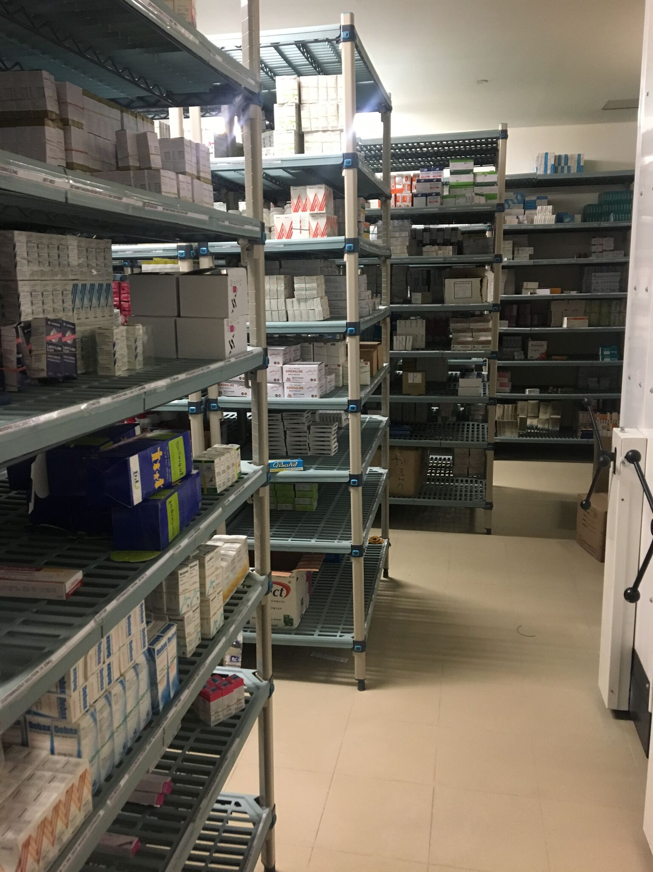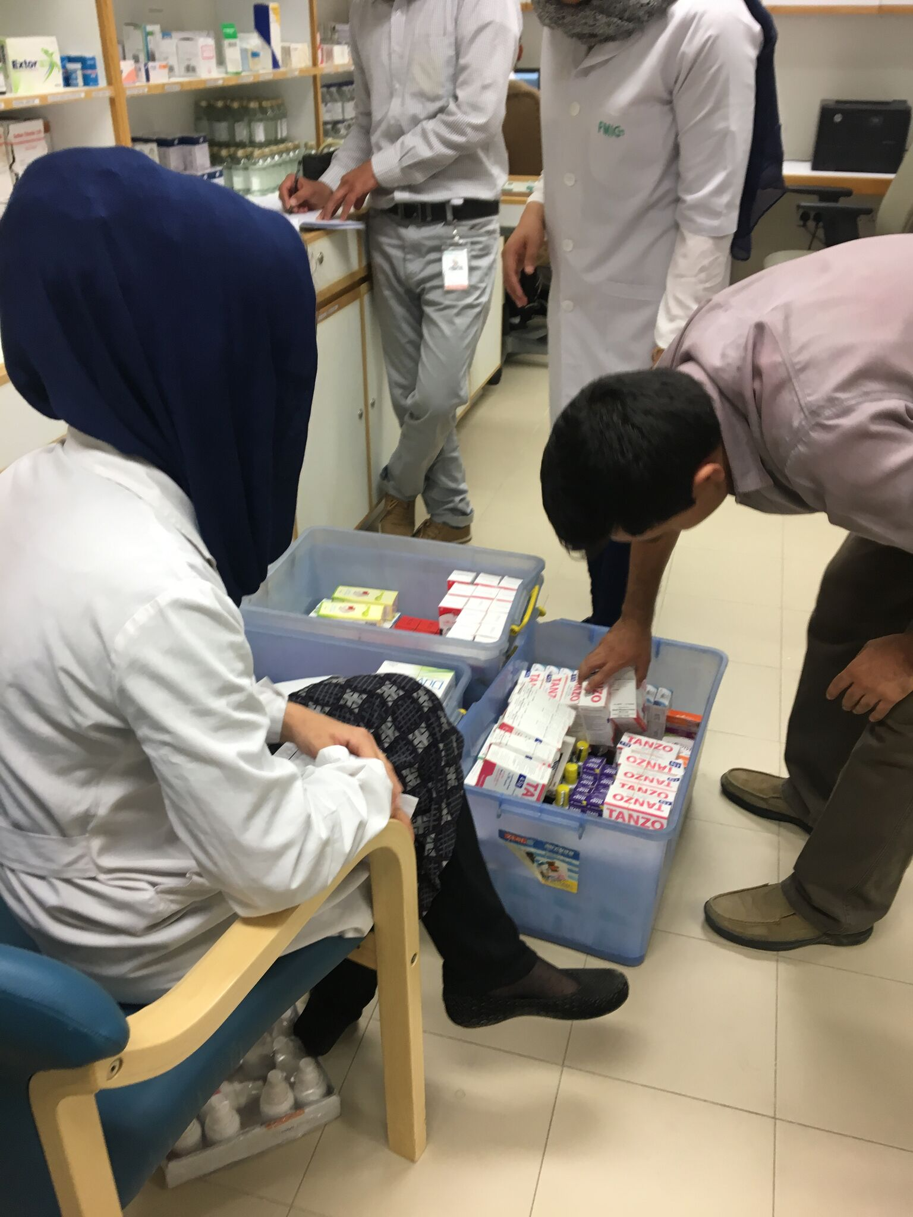
Grand storage in basement, from here every day it is distributed in the 3 pharmacies.

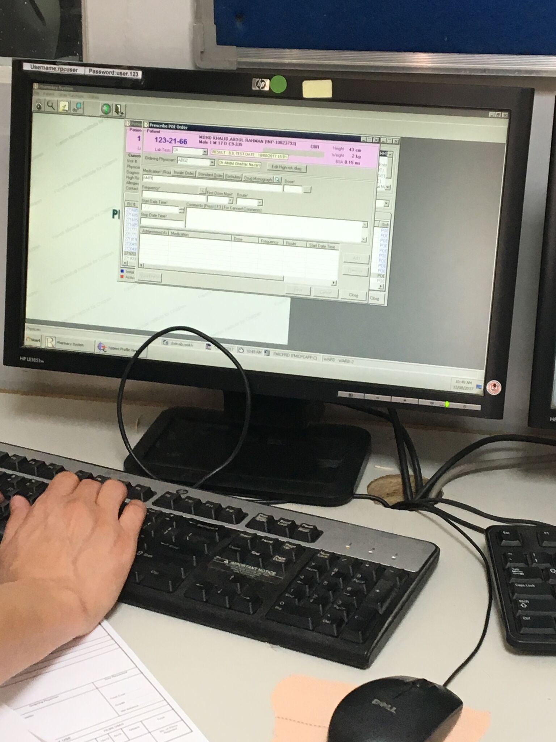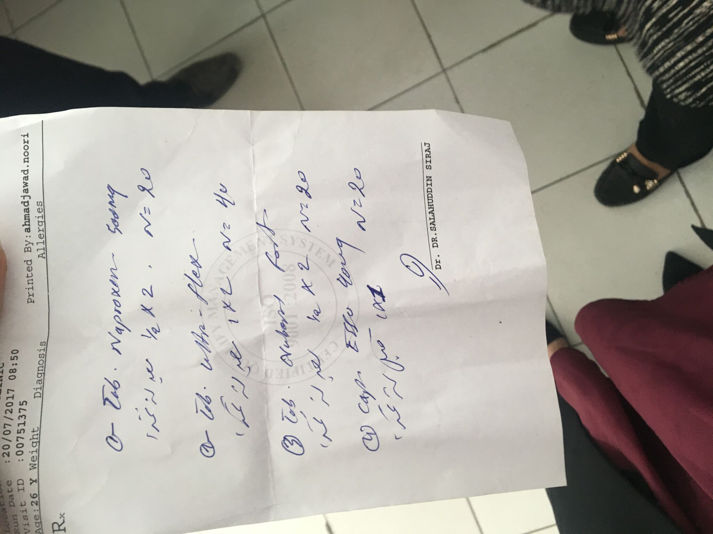

The Dr. fills the Rx prescription electronically if it is in patient goes to the pharmacy system

for the out patient and clinics the prescription is written
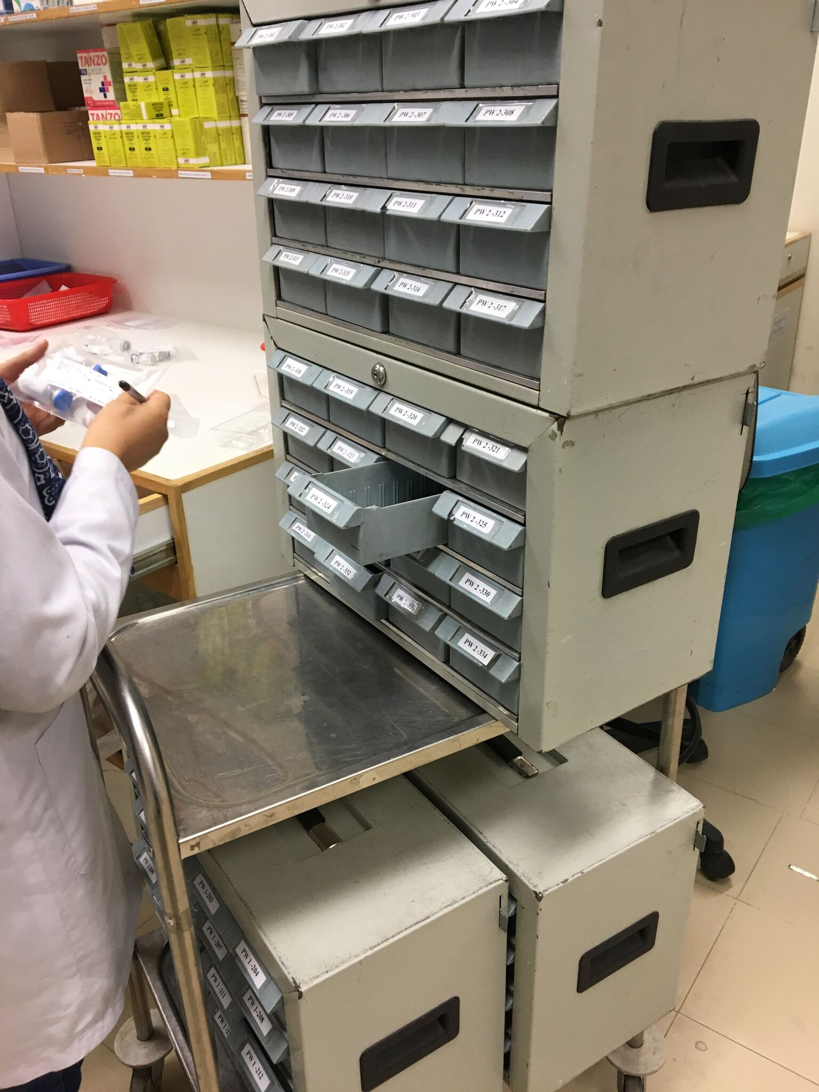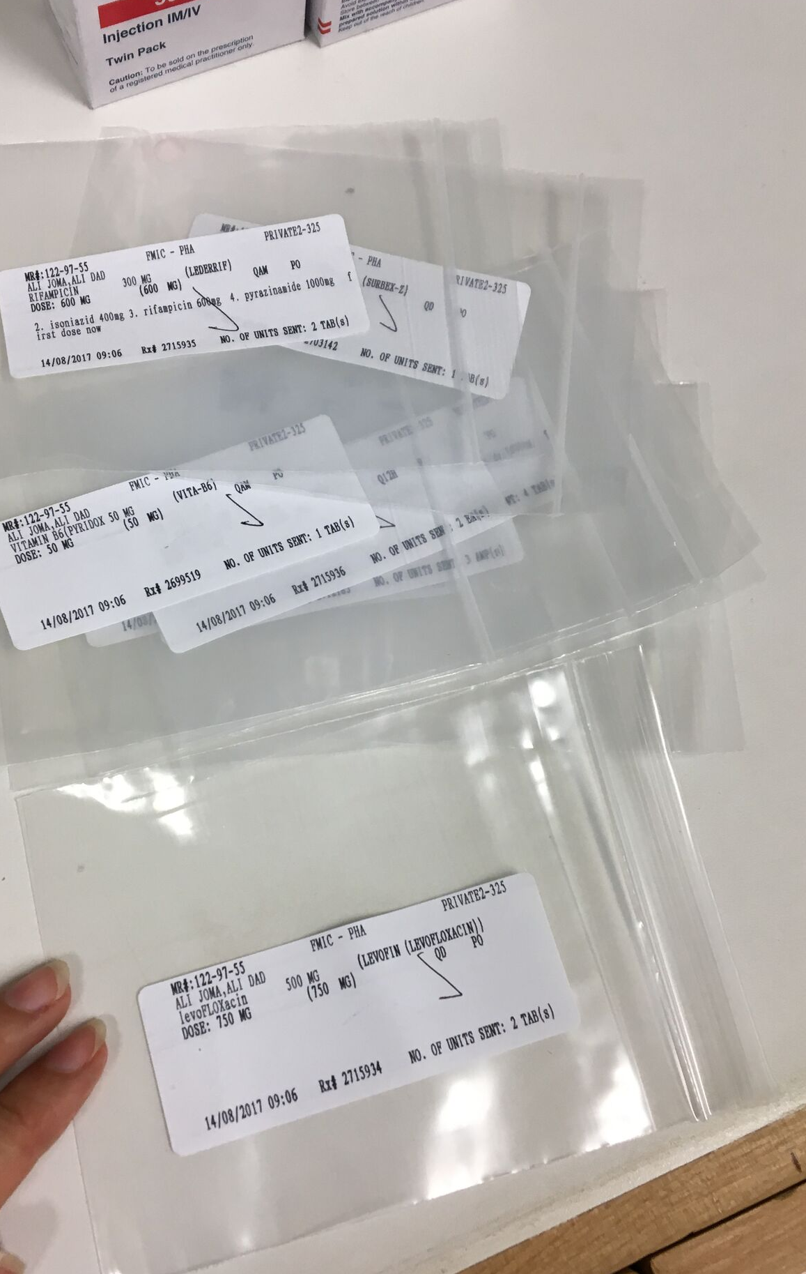
the medication is filled for 24hr in little plastic bags and put in small drawers labeled with the patient room and bed number

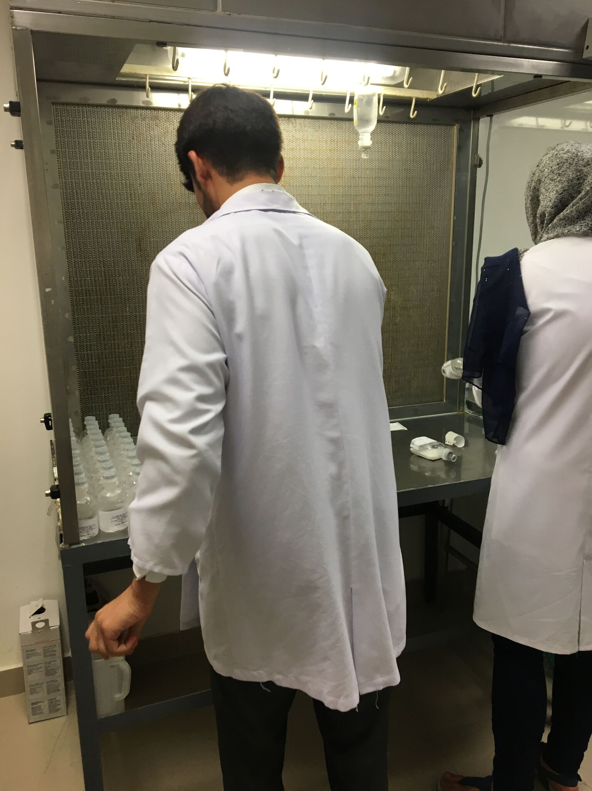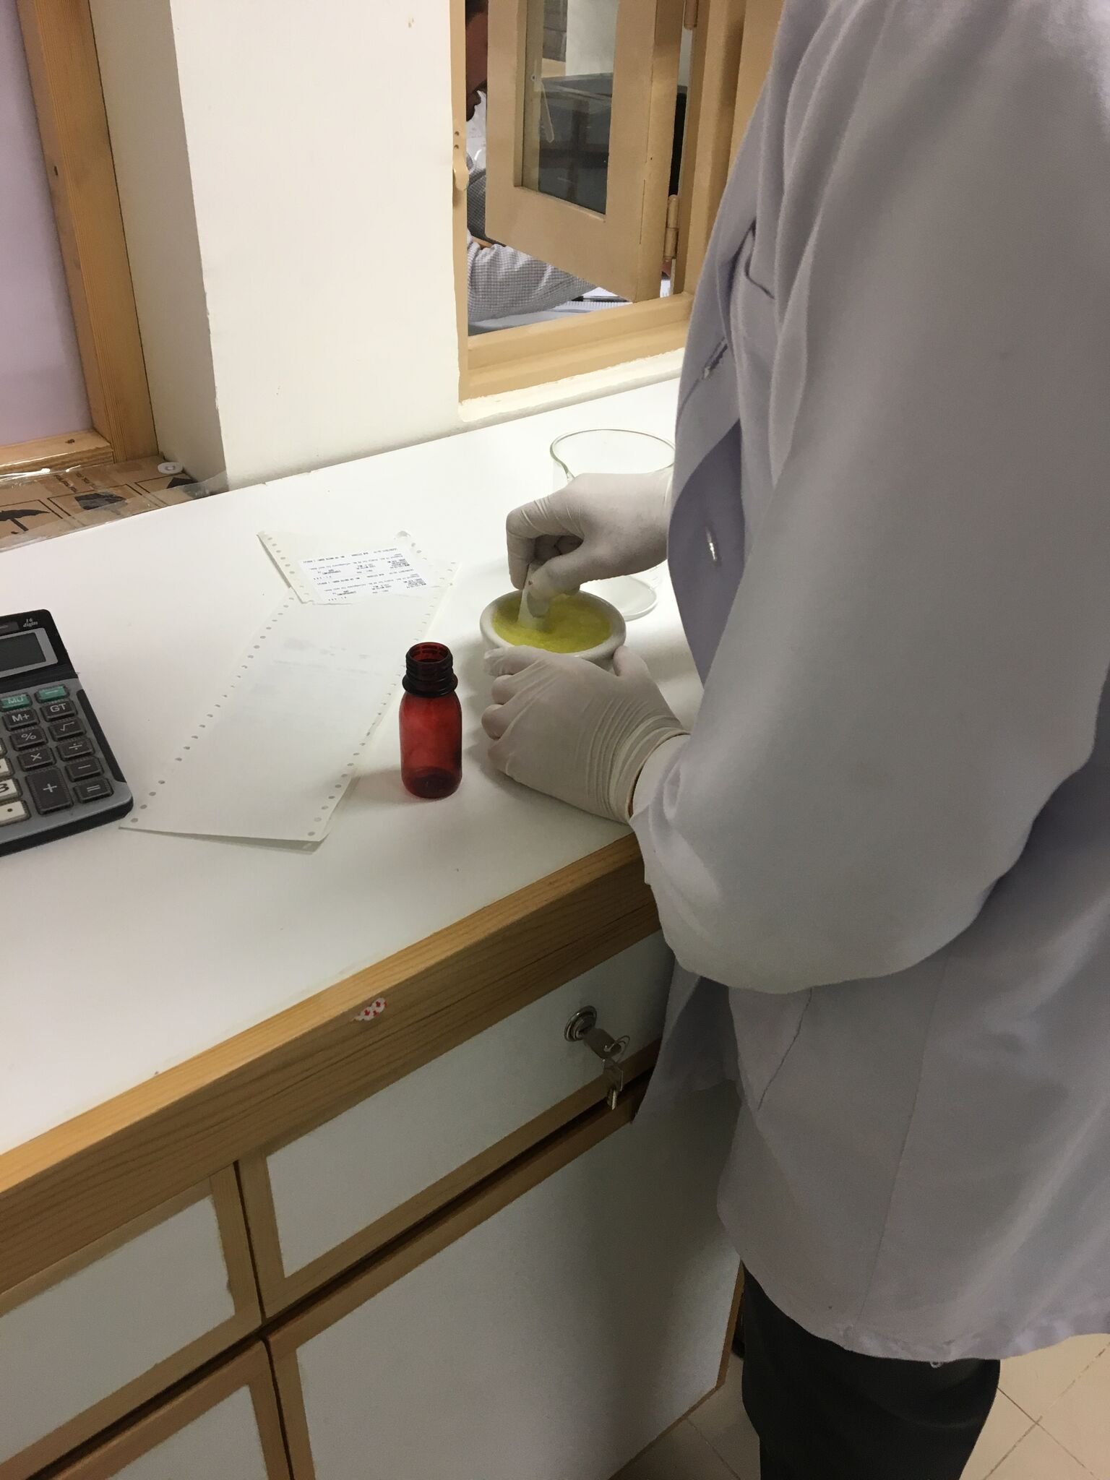
the pharmacy has its own compounding room (as well sterile and aseptic preparation)

