An overview of the Pharmaceutical Field in Rwanda

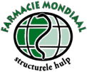

Wietske Hemminga
Master student Pharmacy
University of Groningen
July 2015

Rwanda, officially the Republic of Rwanda, is a country in the central of east Africa with more than 12.3 million habitants (July, 2014) living on a surface of 26.3km². Therefore, Rwanda has the highest population density in Africa. To the outside world Rwanda is mainly known for the genocide which took place in 1994. Rwanda's economy suffered heavily during the 1994 Rwandan Genocide, but has since been strengthened again. The same applies for healthcare, after the genocide the healthcare regained. Rwanda has four referral hospitals, which are Centre Hospitalier Universitaire de Kigali, Centre Hospitalier Universitaire de Butare, King Faisal Hospital and the Kanombe Military Hospital. It also has a number of health centers estimated to be over 440 and 48 district hospitals.

In April 2014 the Royal Dutch Pharmaceutical Student Association (K.N.P.S.V.) had send an email to all Dutch students. This email contained information about a project to visit Rwanda, with the focus on the pharmaceutical field. In May 2014, I applied for this project and in August, I had a selection conversation with Richard van Slobbe from Farmacie Mondiaal (FM). This foundation in collaboration with the K.N.P.S.V. had set up this to interest students for the pharmaceutical field in the third world. This hopefully will lead to new insights for both parties, for the students and for the Rwandan pharmacists.

In January 2015 I visited Rwanda for three weeks, to experience the pharmaceutical care in Rwanda. I visited four locations, which were all related to pharmaceutical health care. Figure 1 shows these locations. I spent the first week at the Hospital in Kinazi and one day at the District Pharmacy in Ruhango, the second week I went to the University of Rwanda in Huye/Butare for two days, followed by a two day visit at the Hospital in Kibogora and the last week I was at Kipharma in Kigali. During my visit to these places, I was not the only pharmacy student, but was with two other pharmacy students from Utrecht, namely Merel Philippart and Endriean Prajitno.
In these three weeks I saw a lot of the pharmaceutical care and the regulatory systems, all my questions were answered by the people working in the pharmaceutical field at the different locations and I told them about the pharmaceutical care in the Netherlands and Dutch system.

What I have seen of the pharmaceutical landscape in Rwanda can be divided into:
- Healthcare system
- Pharmaceutical care
- The pharmaceutical company Kipharma
- Pharmaceutical education

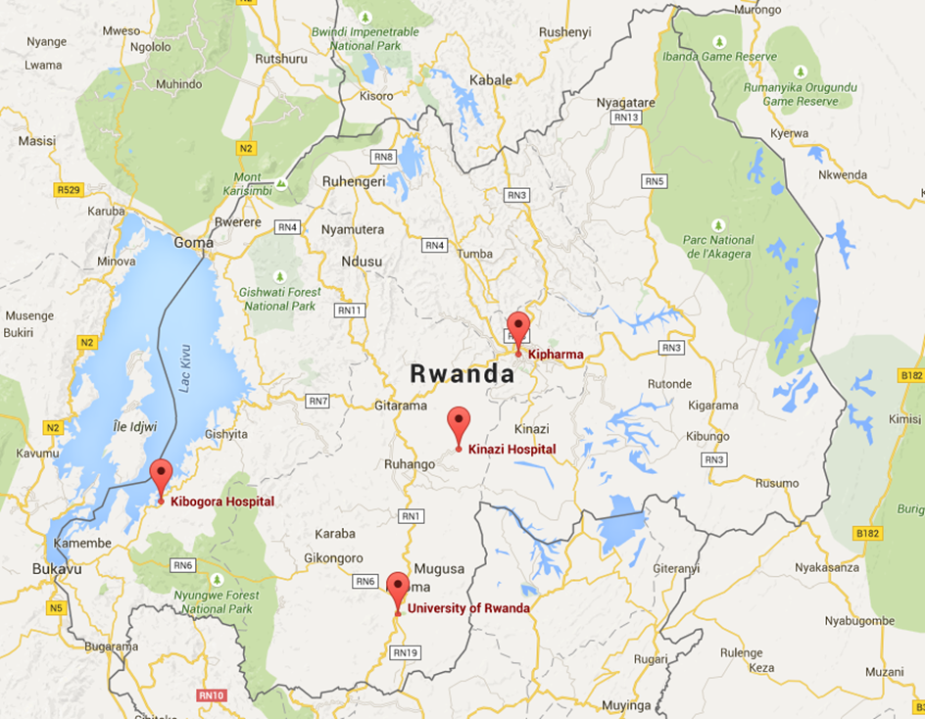
Figure 1: The Rwandan map with the different locations I have visited in January 2015.

Healthcare system in Rwanda
In Rwanda the healthcare is roughly divided into public and private healthcare, this division is seen in the healthcare system and also in the pharmaceutical care.
The health insurance system has become clear to me like is shown in figure 2, this figure shows the different classification of the health insurances. The Ministry of Health of Rwanda has made it possible for all Rwandans to have access to health care which is essential, through the community health insurance, also called the Mutuelle de Santé. To be eligible for this insurance you do not have an employer, nor a job or you belong to the poorest categories, which are based on a community participatory approach. This community health insurance is 3,000 RwF a year per person and when you have more family members you also have to pay 3,000 RwF for them. This insurance will cover 90% of the medication costs.
If you are employed by a government institution, the Rwanda Social Security Board (RSSB) is the insurance organization which will cover 85% of the medicines you need. For this insurance you pay 21,000 RwF every month and the other 21,000 RwF is paid by the government institution.
If you are employed by a company independent of the government, then your employer pays the insurance costs, by keeping these costs from your salary. Then it depends on the company to which insurance company it is connected to and which percentage from the medication costs will be covered, this varies between 50-100% coverage.

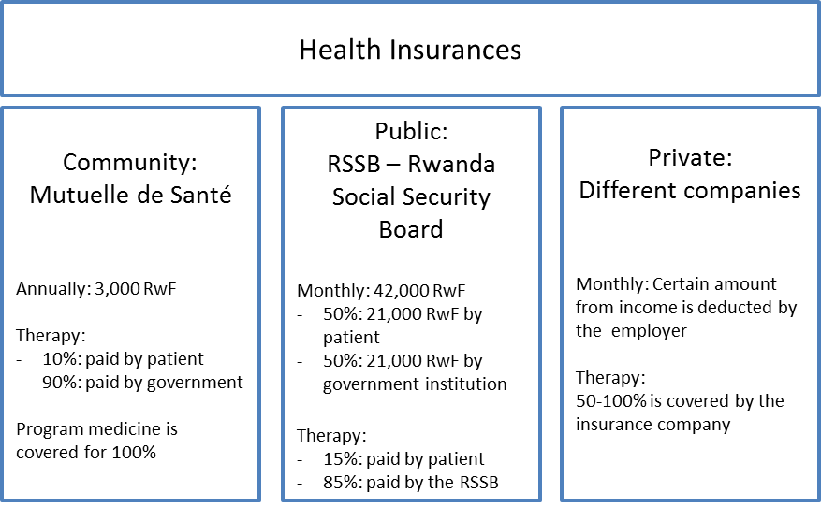
Figure 2: The classification of health insurances

Rwanda is split up in thirty districts and each district has a certain amount to spend for the Mutuelle de Santé, so it depends on the amount of people living in that district who are eligible for this insurance and how much money is obtained from the ministry of health. It differs quite a lot per district if all health costs, the 90% coverage, can be covered by the Mutuelle de Santé and results in delayed payments. Therefore, the hospitals and health centers have to wait for the declared finances from the Mutuelle de Santé, causing a financially shortage for the hospitals. This leads to stock outs, because the hospitals cannot buy their products.

In my view, would be a possible solution to categorize all the people who are eligible for the Mutuelle de Santé and having them pay 2,000 – 7,000 RwF a year depending on the category. But still I think not all costs will be covered in this way.
In the last week of my stay, I have been told the Mutuelle de Santé and the RSSB will merge together, so the people who are insured at the RSSB will pay more to compensate for those who are insured by the Mutuelle de Santé.
Moreover, I was very surprised that this country already developed such a health insurance system! And, I think it is great Rwanda has made it possible to give birth controlling pills, HIV/AIDS and TB medicines for free, preventing the dispersion of these diseases and to treating them.

Pharmaceutical care
To get a certain medicine, you often need a prescription from a doctor, the same applies to the Netherlands. This pharmaceutical care is arranged by different types of pharmacies, like the district pharmacy, also some medicine can be given in health care centers, in the hospital pharmacy and in the private pharmacy. The last one is also called retail pharmacy and will be discussed under the heading Kipharma.

Pharmaceutical supply in the public sector
Like already mentioned healthcare can be split up in public health and private health. Figure 3 shows the supply of the public health sector.

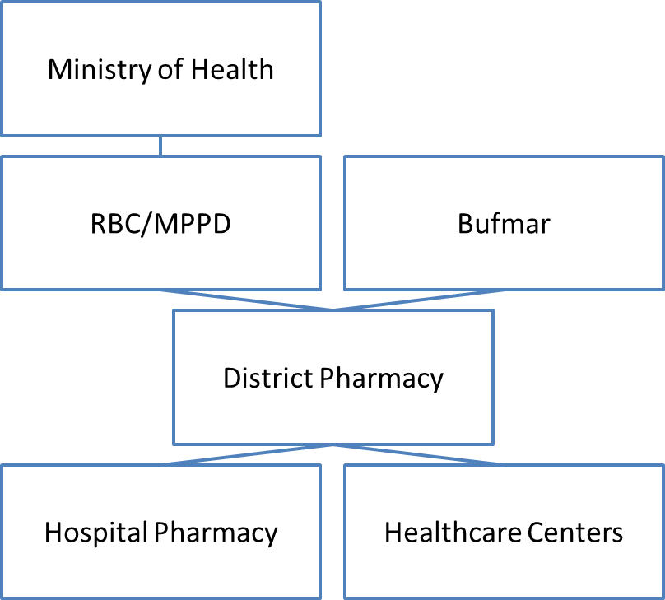
Figure 3: The supply chain of the public health sector

The ministry of health is on top and is responsible for the Rwanda Biomedical Centre (RBC) and the Medical Procurement and Production Division (MPPD). The MPPD buys the medicine with approval form the ministry of health from abroad and serves as a wholesale for the district pharmacies. Manufacturing companies are not established in Rwanda, the MPPD have to buy all product from abroad. Pharmaceuticals are mainly imported from Indian and Kenyan wholesalers. Besides, almost all these pharmaceuticals are generic medicines.
Rwanda is composed of thirty districts and each district has one or two hospitals and 12-20 health centers. Each district has also one district pharmacy, this pharmacy is the supplier for the hospitals and all the health centers in that particular district.
Bufmar also delivers pharmaceutical products to the district pharmacies, mainly the program medicines for birth controlling, HIV/AIDS, malaria and TB.

In January I have visited the district pharmacy in Ruhango, which supplies seventeen healthcare centers and two hospitals, including the Ruhango Hospital in Kinazi. To provide all healthcare centers and hospitals in pharmaceuticals, the district pharmacy has to maintain their own stock. The district pharmacy will place a monthly order at the MPPD, this order need to be approved by the ministry of health. The healthcare centers and hospitals also place a monthly order at the district pharmacy. Often it occurs that the hospital pharmacy needs halfway the month already, needs some new medication, halfway the month, an emergency order is then placed at the district pharmacy.
A common problem is the stock position of the hospitals, district pharmacies and the MPPD. This applies mainly to the essential medicines. It often happens that the hospital pharmacy needs a certain medicine, which is out of stock. The hospital pharmacy then needs to borrow it from another hospital or another district pharmacy, where it is in stock. This takes a lot of time, the distances between the hospitals and the district pharmacies are large. When another hospital or district pharmacy have the medicine in stock and there is also a stock out at the MPPD, the hospital pharmacy can buy it in the private sector. Buying from a private pharmacy, the hospital pharmacy need to have permission from the ministry of health. Often it takes five or more days to get permission. This takes too much time, especially, when human lives depend on this medication.

Eugene Kayitesi, the pharmacist from the Kibogora Hospital, told me the problem is at the MPPD, they have to buy more different products, so the district pharmacy will have all kinds of pharmaceuticals from the essential list. Nowadays Eugene buys 50% from his products at the district pharmacy and the other 50% he has to buy in the private sector, because of the unstable stock at the MPPD and district pharmacy.
Adeline Kazayire, the pharmacist from the Ruhango Hospital in Kinazi, told me she gets 14% of her order at the district pharmacy from the MPPD, the other 86% has to be bought in the private sector with permission from the ministry of health. She said the same as Eugene about the MPPD, they should have more kinds of medicines and more amount of the medicines.
To buy in the private sector takes a lot of time, you need the permission which costs five days and you have to buy it at a private pharmacy or wholesale like Kipharma in Kigali, which takes a lot of time to travel to. Because those pharmacies are mainly not found in rural areas. I think this time should be used for other tasks, like pharmaceutical care for the patient.

Organization of the healthcare
Healthcare is given in healthcare centers and hospitals, the big difference between those is in the healthcare centers is that you can get only some simple medication like acetaminophen and the program medicines, like the birth control pills, malaria, HIV/AIDS and TC medication. In the healthcare centers nurses are the only healthcare professionals, in the hospitals you will find nurses, doctors and one to three pharmacists. In terms of medication the hospitals should have all the essential medicine available, but given the unstable stock position of the MPPD and the district pharmacies not all the essential medicines are in stock.

The ministry of health has set up the Rwandan Hospital Standard, in order to maintain the qualitative healthcare in all the Rwandan hospitals. These standards consist of five areas, where attention should be paid to:
- Leadership and accountability
- Capable workforce
- Safety environment for the patient and the staff
- Clinical care
- Quality improvement

During my stay in Rwanda I visited two hospitals, especially the hospital pharmacies. Differences with the Netherlands were the tasks of the pharmacist in some parts, the part which differs the most is the logistical part. In the Netherlands we use automatic systems, almost everything is digital. In Rwanda as I have seen this part is almost the main task and it takes a lot of time.
The administrative work consists of keeping track of two systems: the dispensing system and the stock system. These systems do almost the same thing but are working in a different format. The dispensing system is relevant for the ministry of health for the insurance declarations and the stock system is also obliged by the ministry of health, so they can check what you order at the district pharmacy. This stock system has one big struggle, you need internet access to log on into the system. Because of an unstable internet access this takes a lot of time, this system is often updated afterwards. For the order at the district pharmacy an Excel list is also being kept, which is based on the list from the dispensing system. A difficulty is that the dispensing system and the Excel list for the order at the district pharmacy are in French and the stock system is in English, this creates confusion and higher risk in making errors.

To create an image of the tasks of a hospital pharmacist, I have written down the time schedule of Adeline Kazayire.

7.00 Staff meeting
- The number of patients at the hospital
- Kinds of treatments (once a week: DTC*)
- Issues happened during the night (transmission of patients)

7.30 Pharmacy
- The staff meeting shows which treatments are started and which medicines are needed. These medicines must be looked up in the dispensing or the store, or when it is out of stock these medicines need to be ordered at the District Pharmacy or obtained from another hospital
- Check the dispensing if everything is in stock, otherwise there will be a transfer from store to dispensing

9.00 Office: Stock management
- All medicines that are given to the patients or to the different hospital departments at the dispensing is written down, this list is transformed into an excel sheet
- This excel sheet is used for the digital system, to fill in all products that are used in the dispensing and which are transferred from store to dispensing
- The digital system is used for stock management at the store and for ordering at the District Pharmacy

12.00 – 13.00 Break

13.00 – 17.00 Visit hospital departments
- Receiving the order lists from the laboratory, radiology, etc
- Clinical visits, supporting and advising the doctors (only when there is time)

*DTC: Drug Therapy Committee
This is a weekly consultation between doctors and the pharmacist, about treatments and the corresponding medication.
Which medicines the doctors can prescribe, because these medicines can be ordered at the District Pharmacy. And which medicines are the best options for some treatments.

Clinical visits are hardly done, due to lack of time. This time is taken up by the digital system, which only works with an internet connection. The modem also often gives very slow access, this takes a lot of time and that is why the digital system does not work properly. And the other time consuming thing are the stock outs, Adeline travels to get the medicines elsewhere, which takes the time reserved for the clinical visits.
In the conversation with Adeline about her tasks she would like to have more time for the clinical aspects. Besides, she mentioned she is the only pharmacist in the Ruhango Hospital and she thinks it is hard to discuss with the doctors about the medication of a patient. The doctors are with more and just want the medication they prescribed, without thinking of other solutions or other medication which are in stock. Then Adeline will go and get the specific medication, while she sometimes thinks another solution will be better, it is hard for her to communicate that.

The pharmacist from the Kibogora Hospital, Eugene told me each pharmacist is obliged to participate in certain committees. He is in the drug interparty and the health & safety committee. These committees takes a lot of time, together with the stock management, time remaining for the clinical aspects is very limited.
I have also spoken with Eugene about the role of a pharmacist, he told me he is the supervisor from stock to dispensing and he is thus responsible for both this task and the orders to the district pharmacy. His ideal view is to have two pharmacist in each hospital, one responsible for the stock management and all the logistics and one responsible for the clinical aspects of the patient, the medical treatment management. When there comes another project, Eugene would like to have a Dutch student for two or three months, who will mainly point at the clinical aspects and that he can learn from how the student addresses these cases.
Therefore, I asked Eugene after my visit to list out the major medicines which are prescribed by the doctors in the hospital. So, when another student will go to the Kibogora Hospital can already make a list of all contra-indications and interactions between those medicines. Below the list of the most used medicines.

- Acetaminophen (Paracetamol)
- Aminophylline
- Ampicillin
- Aspirin
- Captopril
- Carbamazepine
- Ciprofloxacin
- Cloxacillin
- Depakine
- Doxycycline
- Furosemide
- Gentamicin
- Glyburide (Glibenclamide)
- Hydrochlorothiazide
- Ibuprofen
- Insulin
- Metformin
- Metronidazole

Kipharma
I spent the last week of my visit at Kipharma, this company consists of three branches:
- Kipharma Human Health, functions as a wholesale of pharmaceutical products for private pharmacies and also the public health
- UniPharma Private pharmacies at two locations from Kipharma
- Agrotech Animal Health and Agro chemicals (seeds and hybrid seeds)

Kipharma owned by Giovanni Davite and Giancarlo Davite, is a wholesale in Rwanda for pharmaceutical products and consumables for the private and also public sector. The main supply is to the public sector the MPPD, district pharmacies or to the hospitals. Kipharma is part of the private health sector and therefore I expected Kipharma to mostly supply the private pharmacies. But the public sector is a major customer of Kipharma, because the MPPD or district pharmacy is often out of stock of a certain product, therefore the hospital pharmacies have to buy the product from the private sector.
There are no manufacturing companies in Rwanda and the wholesale of pharmaceutical products for the private pharmacies are Kipharma and Bufmar. Kipharma have a small manufacturing laboratory where only creams are made, liquids and smaller packetizing, especially of dermatological products. The raw materials and the other pharmaceutical products for Kipharma are supplied by the pharmaceutical industries in Europe, see figure 4. Kipharma has 25-30 suppliers, the logistics which are needed to get all those different medicines form different places into one ship to Kenya and then by truck to Rwanda is a big job. This supply chain is managed by two teams. Vulnerable medication or emergency orders are transported by plane, leading to more costs.

I spent the last week in Kipharma together with Endriean and Merel. We split up after our first day at Kipharma. Endriean was mainly at the laboratory, Merel had her interest in the supply chain and I went to the other location of Kipharma, a retail pharmacy located in Kishimenti. There I spoke to the pharmacist Jean Damascène, he explained to me how the supply to the Unipharma, which is the company of the two retail pharmacies, is organized, see figure 4. Unipharma also buys outside Kipharma, for 75% some generics are bought for those people who have a private insurance, but have to pay still a certain percentage, which will make brand medicine expensive. Therefore, also some generics are available for those patients who cannot afford the brand.

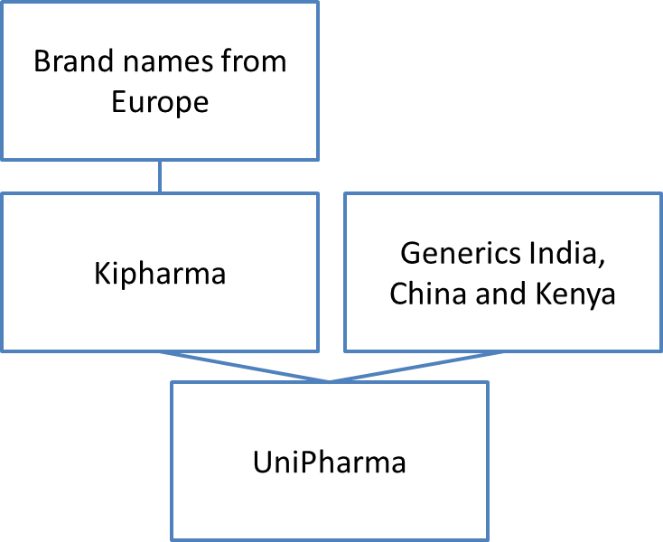
Figure 4: The supply for UniPharma

Jean also showed me the ICT system Ishyiga, through this system the declaration is preformed to the health insurance. It looks quite simple, you look for the right patient, if he has already an account, otherwise you can create one, in which the private or RSSB insurance has to be filled in. Then you click on the certain medication and it tells you the price the patient have to pay and creates also a declaration to the health insurance.

I have had a conversation about improvements with Jean and Richard Bugingo from the other UniPharma location, Nyarugenge, which is located next to the whole sale Kipharma.
I have made a short list of the improvements Jean and Richard would like to see.

Improvements Richard Bugingo:
- Improve Image
  - More different kinds of medicines
  - More in store
  - Cosmetics
  - Arrangement of all medicines and other products Appearance

- Barcode scanning
When there are many people working at the counter, sometimes the wrong medicines are grabbed. This mistake should be avoided.

- Stock out
Is there an easy way to find out whether other pharmacies still have the searched medicine in stock?

- Patient registration
Register the patients into the system, when they become a regular patient, the pharmacist can keep track of all the medication.

Improvements Jean Damascène:
- Software
Nowadays the Ishyiga software is only used for stock management. It would be nice if the software also could be used for more, like the information about all medicines, the effects, the side-effects, contra-indications, interactions, etc.

- Education
There is no extra education or masters for the retail pharmacy, these jobs haves their own topics and there should be improved more, that is only possible with more knowledge, so more specific education

- Professional look
  - Not only selling the medicines, but know everything about the medicines
  - Health care specialist
  - Investing in customer relations patient registration

Both pharmacists would like to improve the same things. And the digital environment plays the major role in these improvements. An ICT-professional could improve the Ishyiga system, so the already existing patient account will also keep track of all used medicines. This could be coupled to a barcode system, such a system was already in use for one health insurance, so the possibility to implement this is already there. Even, the system can be used for stock out, when other pharmacies are using the same system you can look into each other stock.
This improved system contributes also to the professional look, a patient will now know that the pharmacist will check on interactions when the patient is registered.
And in the future when the access to the internet will be better, you can implement that a patient can order his medication and your stock management will be adapted to these orders.

In my view these improvements are worth striving for and maybe possible in the future. Education about contra-indications and interactions is always a good thing to refresh their knowledge about it. Besides, if the system is not improved yet, the nurses and pharmacists can ask to the patients what they already have been using in terms of medication to give the patient an explanation about possible adverse effects, interactions and contra-indications. I think these questions are the things to start with.

Richard is also in the Rwandan Pharmacy Counsel (RPC), this counsel is established in 2013 and is responsible for the registration of a pharmacist. To become a pharmacist you need a license to practice, which costs a certain amount a year and to get the license each year you have to comply with the requirements of the continuous professional development (CPD) to achieve a certain amount of credits each year.
Richard his role in this counsel is on the field of pharmacy law. He has to decide about the pharmacist who has made for example a medication error, if this pharmacist still can retain his license to practice. This committee consist of five pharmacist and the RPC consist of six more committees, like Registration, Disciplinair, Economics, Regulation, Education and Research.

I think this counsel is important, it is a good thing there is a controlling organ for the profession, because the wrong medication could kill the patient.

Pharmaceutical education
To become a pharmacist, you have to succeed the study Pharmacy at the university. A bachelor degree can be achieved in five years. In the first four years there is a main focus in theoretical subjects like biochemistry, organic chemistry, logistics and pharmacology. The fifth year consist of several internships, two months in private pharmacies, two months of supply chain management or stock/store management and four months of in a hospital pharmacy. During the fifth year the students also have to write their bachelor thesis, when they have completed their internships and their thesis they can work as a pharmacist. A master degree can be achieved in one or two years in Kigali or abroad, often in Uganda or Europe, in Belgium of Germany. Differences with the Duth system are the duration of the study, five years for a bachelor degree against three years, many theoretical subjects against many hours of laboratory practice in the Netherlands and Rwandan students do not need a master degree to become a pharmacist.

My visit to the university consisted of a welcome by the Department Director Dr. Egide Kayitare and the Dean of the faculty of Medicine Dr. Patrick Kyamanywa, a tour around the university by the president of the student association Israel Bimpe, a tour at the laboratory and a lecture we (Merel, Endriean and I) gave about pain management to the students. During the talk with the Department Director the structure of the study Pharmacy in Rwanda became clear to me, like already is mentioned. After what I had seen in the Hospital pharmacy in Kinazi about the tasks of a hospital pharmacist, which are mainly logistics, I asked the Department Director whether students are also taught about this logistical tasks. According to him the students have some courses about logistics in the third and fourth year and therefore during the internships a great attention on this topic is paid. The internship in the hospital is the main internship of four months to bring the logistical tasks in practice. In the conversation also came forward the that fifth year students can choose a topic of their own interest in the pharmaceutical field. I had the opportunity to read various theses and a thing I noticed was that almost all these theses were literature-based. Most of the students have to choose for a literature-based thesis, because this type of thesis can be combined with the internships done at the same time. Another reason is when you would like to do your research in the laboratory, the university lab only have a few places available. The usage of another laboratory can often not be financed by a student, considering that the student have to pay for the usage.
My visit on January 13th was during the examination week, therefore I was not able to attend a lecture and it remained by a tour around the university and the laboratory. The laboratory building consisted of four laboratories, each with their own kind of research and where over twenty students per lab can do their practicals. During the conversation with the head of the laboratory, we were told he was the only practical lecturer. He had done his master in Belgium and France and have studied in the analytical chemistry and have learned everything about the analytical device High Performance Liquid Chromatography (HPLC). He supervises the students during practicals and thesis in the laboratory. He only can supervise around ten students during their practical tasks, because helping them with their research takes a lot of time and attention. That is why there are so few places available to do practical thesis. He also mentioned the students have too little experience in practical research to do their thesis at the laboratory. This is because of the students do not practice themselves during courses in the first year to the fourth year, or if they practice they are with a group of twenty students working one analytical device. Reasons for this system are mainly because, he is the only one who knows everything about the devices and reagents, other reasons are the amount of devices and the costs of all materials.

I was asked to prepare a lecture for the students. Beforehand it could not be said in which year the students are, whom I would be giving the lecture to. In addition, Adeline had also given me the topic pain medication to present. Merel and Endriean had received different topics. But after what we had seen in the hospital in Kinazi, we thought it was a better idea to discuss only about pain medication. We thought this topic deserved the most attention and for the students it is more clearly when one topic is highlighted. So we gave a on pain management, that consisted of three parts. Part one was presented by Endriean about what is pain and how does it occur, I presented part two about NSAIDs, about the mechanism, adverse effects and the interactions. And Merel presented part three about Opioids and the pain ladder according to the WHO. Despite the exams many students came to listen to our presentation and were curious about the Opioids because they do not know much about this type of medication.

I see some opportunities to improve the educational system. Apart from my consideration that there must be drawn one line worldwide in terms of the duration of the study pharmacy, the schedule of this five-year bachelor could differently be filled. I think the fifth year is too much, eight months of internships combined with a thesis. Both elements the internships and the thesis, deserve attention and in my opinion these two elements do not have to take place during the fifth year, but the thesis can be done next to other courses in the fourth year. To become a pharmacist, internships are from high relevance. Besides, the study pharmacy is at the university at a scientific level, therefore a thesis should comply with appropriate standards of scientific research. In my view, also practical skills belong to a pharmacist.
To ensure that all students are having these practical skills more practical courses in the first year to fourth year should be given. To teach all students more lecturers are needed, I think there is another solution. This might take some more time in the beginning, but afterwards it gives many advantages. The solution is called student-assistant, these are senior students who already have the knowledge of the analytical devices and the practical skills and these student-assistants can teach the first year students. In the beginning it takes time to train those senior students to become a student-assistant, but once trained, the first year students know already something about the practical skills and can become a student-assistant in a subsequent year.

Another thing like I already mentioned and had a conversation about with Richard Bugingo and Jean Damascène from Kipharma is the role of a pharmacist. I have seen the role of a hospital pharmacist, which mainly consisted of the performance of logistics. While I think a pharmacist is a healthcare professional and knows everything about medication. Given the conversations with Richard and Jean who also think about the role of a pharmacist, I wonder whether this debate will be discussed during the study pharmacy.

Conclusions and recommendations
Rwanda is a beautiful country and in terms of healthcare this country runs ahead in contrast to the neighboring countries. The insurance system is well organized and I hope the merging between Mutuelle de Santé and the RSSB will provide better coverage of all costs. For the supply chain in the public health and for the prevention of stock outs something needs to be changed at the ministry of health. The same involves the stock management with the different systems, only from above at the ministry of health improvements can be made. On a small scale pharmacists at the hospital can manage their tasks and let the nurses do the travel to other hospitals or pharmacies to get the medication, so they have more time for the clinical aspects of the patient.
In the private pharmaceutical sector the system Ishyiga should be extended and it should not only be used for the payment of the insurances, but also for the patient data, medication records and interactions. By this system improvement, the role of a pharmacist will be more like a healthcare professional.
Also at the university they have to learn about this role and what the best pharmaceutical care for each patient is. Besides, the student have to develop more practical skills and should have the chance of doing a research where practical skills are involved.
I think, because the changes needed at the top at the ministry of health are not addressed yet, but may be made in the future, it is difficult to implement all the improvements. Therefore, as an intermediate solution, the students, but also the pharmacist should get the chance to take a look at the pharmaceutical care system in the Netherlands. They can see the thing they would like to use and afterwards implement them in their own system.

Acknowledgements
Jurdas and Adeline many thanks for your help at the preparation and guidance during these three weeks of my visit to Rwanda. Thanks to everyone who were so kind to show me those things in the pharmaceutical care Rwanda stands for.
And also my special thanks to Farmacie Mondiaal who supported me and has made it possible for me to visit Rwanda.

