Rwanda Student Exchange Project

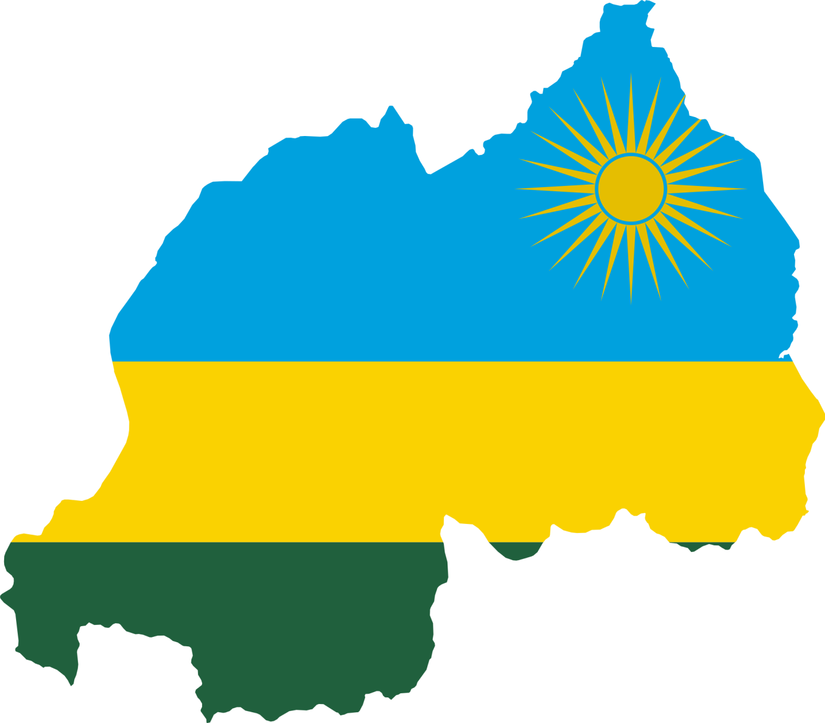

Student: Thijs Balk
Visited: January 2016

Table of contents
Project plan 3
Healthcare in Rwanda 4
Project activities in Rwanda 5
Kipharma & Unipharma 5
Kibogora Hospital 7
Pharmacy department at the University of Rwanda 9
University Teaching Hospital Kigali 11
Reflection 12

Project plan
This project is the result of a cooperation between the Royal Dutch Pharmaceutical Students Association (K.N.P.S.V.) and the global pharmacy foundation Farmacie Mondiaal (FM). The idea is to exchange pharmacy students between the Netherlands and Rwanda to obtain a better understanding of pharmacy practice in both countries. Unfortunately at this moment it is not possible for Rwandan students to come to the Netherlands for this project, so for now only Dutch students visit Rwanda to exchange knowledge.

The project consists of a period of at least three weeks in which different aspects of the pharmacy field will be explored. There are four organizations in Rwanda participating in the project. It is the responsibility of the students to discuss the period of travelling and the exact planning with the contact persons in Rwanda.

FM is supporting the Dutch students financially. They are also available in case of any problems in the preparations for the project or during the project in Rwanda.

I participated on this project from the 30th of December 2015 until the 22nd of January 2016. During my stay in Rwanda I visited several places:
- Kipharma, a wholesale and community pharmacy in Kigali;
- Kibogora Hospital, a district hospital in the South-West of Rwanda, Kirambo district;
- Faculty of Pharmacy at the University of Rwanda in Huye;
- University Teaching Hospital of Kigali, a referral hospital in Kigali.

In this report I will describe my stay in Rwanda. I will also try to note some possible improvements.

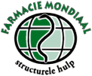

Healthcare in Rwanda
In 2000 a government development program was launched in Rwanda by the Rwandan president Paul Kagame, called Vision 2020. One of the goals of this program is to reduce health problems within these 20 years. In the Vision 2020 is described that a healthier population is needed to build a productive and efficient workforce which is essential for Rwanda to become “the sophisticated knowledge-based economy”. The clear objectives are:
- Reduction in infant mortality rate from 107/1000 to 50/1000;
- Reduction in maternal mortality rate from 1070/100.000 to 200/100.000;
- Life expectancy will have been increased from 49 to 55 years;
- Malaria and other epidemic diseases will have been controlled;
- Aids prevalence will have been reduced from 13% to 8%.,

The health care facilities are much better than I expected. Even after one hour of driving on a dirt road you can find big health centers with physicians, healthcare workers, physiotherapists and a pharmacist. The improvement in healthcare has been made during the years after the genocide by investing 6,5% of the country´s gross domestic product in 2013 compared with 1,9% in 1996. This resulted in achieving already some goals in 2013:
- Life expectancy increased to 64 years old;
- Infant mortality rate decreased to 52 per 1000;
- Incidence of tuberculosis decreased from 101/100.000 to 69/100.000.

These statistics make clear that Rwanda is really improving healthcare, but still more progression is possible. For example, the HIV prevalence has not started falling since 2015, while I noticed during the project that a HIV-test and medication is offered for free by the government. This might be explained by a report by the Rwandan government that showed that not everybody has access to antiretroviral therapy (ART): 86,6% of eligible adults and only 53,9% of eligible children. Major problems in the access to ART are the medication supplies, follow-up and late diagnosis. Only 1/3 of the health facilities that are offering ART had uninterrupted supplies, so in 2/3 of those facilities stock outs occur. Thereby in most of these facilities there is insufficient information and clinical follow-up for children with HIV. Also the Ministry of Health reported that HIV-positive children are diagnosed at a late stage.

However much still remains to be done, the achievements made for the past years, do impress me. The government pays a lot of attention to healthcare (policy and financially) and education, this makes that the infrastructure, the availability of medication and knowledge are available. In my opinion those are some of the key conditions to support (local) pharmaceutical healthcare by an organization like FM in an efficient way.

Project activities in Rwanda

Kipharma & Unipharma
Unipharma is a community pharmacy in the city center of Kigali. It is a big pharmacy and it is told that it is known for good quality drugs. In the same building the wholesale Kipharma is located which is also focusing more and more on compounding. The directors of both companies are Giovanni Davite and Giancarlo Davite.

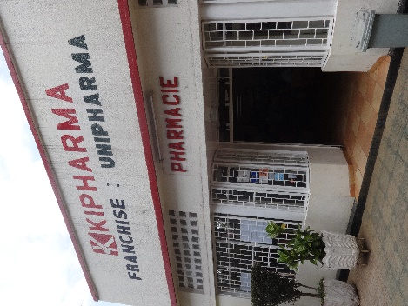
On Friday the 2nd of January at Kipharma we met Richard Bugingo, our coordinator in Rwanda and also the one in charge of the community pharmacy, for the first time. He told us about the plans for next week and he showed us around in the pharmacy and wholesale.

The community pharmacy was better organized then I expected in Rwanda. There were more computers than I usually see in a Dutch pharmacy and they all have a device to scan insurance cards and fingerprints.

When a patient gives his prescription to the pharmacist (assistant), the medication is entered in the computer system. The system tells you whether the medication is in stock and what the costs are. If it is not in stock the computer system can tell you in which other pharmacy there is a stock. The insurance of the patient is checked by reading the insurance card via a special device, which shows in the computer system what amount the patient should pay (around 10-15%) and what is covered by the insurance. So every patient has access to the most essential medication, but always has to pay 10-15% depending on his/her insurance. An exception is HIV/AIDS medication, which is offered by the government for free.
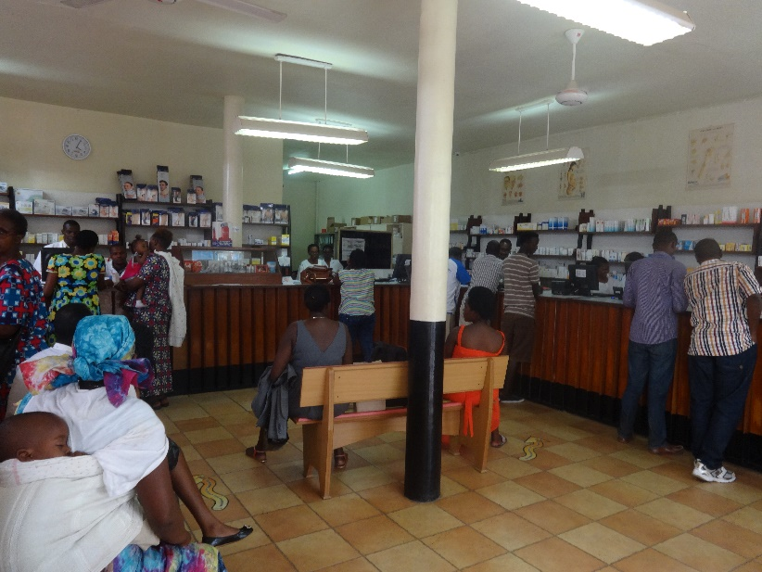

The patient waiting area at Unipharma
Then the pharmacist will give the medication and also the prescription so the patient is able to read the dosage later. The pharmacist tells the patient how to use the medication, but no leaflets are given. The pharmacist also doesn’t check the dosage or drug-drug interactions. The pharmacist told us that they sometimes ask the patient what other medication they use to check for interactions, but they only have access to some books, so only if they know an interaction right away they will do something. For example, in case of long term use of NSAIDs they do advise a proton pump inhibitor. In this case more advanced computer software could improve medication safety. As most pharmacies have a good internet connection and computers, the most important conditions are met to introduce a system that also focusses on medication safety.

Furthermore we visited the different departments within the wholesale Unipharma. There is a compounding unit where they produce mostly dermatics. Protocols were available in a binder, but those were mostly used as a reference book. They increasingly produce big stocks of indifferent dermatics to supply other pharmacies and several hospitals (of which Kibogora Hospital and University Teaching Hospital Kigali).

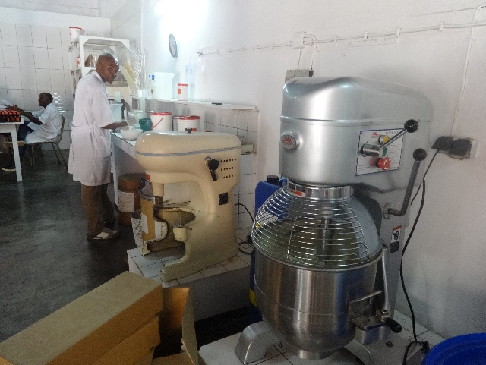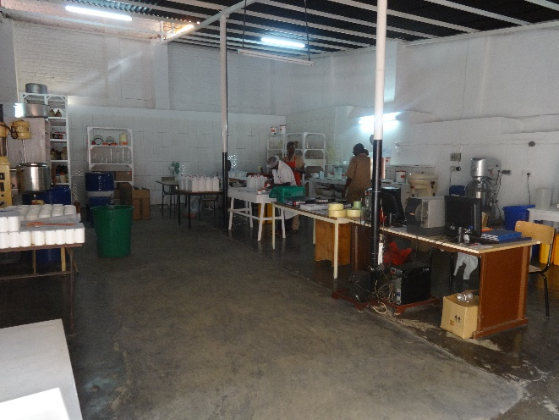

Left & right: The compounding laboratory and its equipment.
It is a matter of fact that medication in the Netherlands is easily available and stockouts are often solved within some days. The wholesale in Rwanda has to plan three months ahead, because they have to import everything by ship from Europe or India. To import in a cost effective way, two employees at Kipharma are fulltime managing those orders. Ida is responsible for forecasting the stocks and Beatrice is the logistics officer. She is responsible to fill the containers to be shipped as efficient as possible. Due to much higher costs they try to prevent that they have to import medication by plane.

At the sales department Lambert is in charge. In the same department Jean Pierre is focusing on tenders, so he communicates with (potential) clients and tries to bind them to the company.

Recommandations
As medication is dispensed without any check I would advise to improve the medication safety. At Unipharma there are always several assistants and a check can be done fast. At this moment just one assistant or pharmacist sees the prescription and gives the medication to the patients. It is easy to make mistakes in this process, but also easy (and without extra costs) to prevent this by implementing a check. In Rwanda the prescription is given back to the patient, so nobody is able to check the dosage on the prescription and whether the given medication corresponds the prescription.

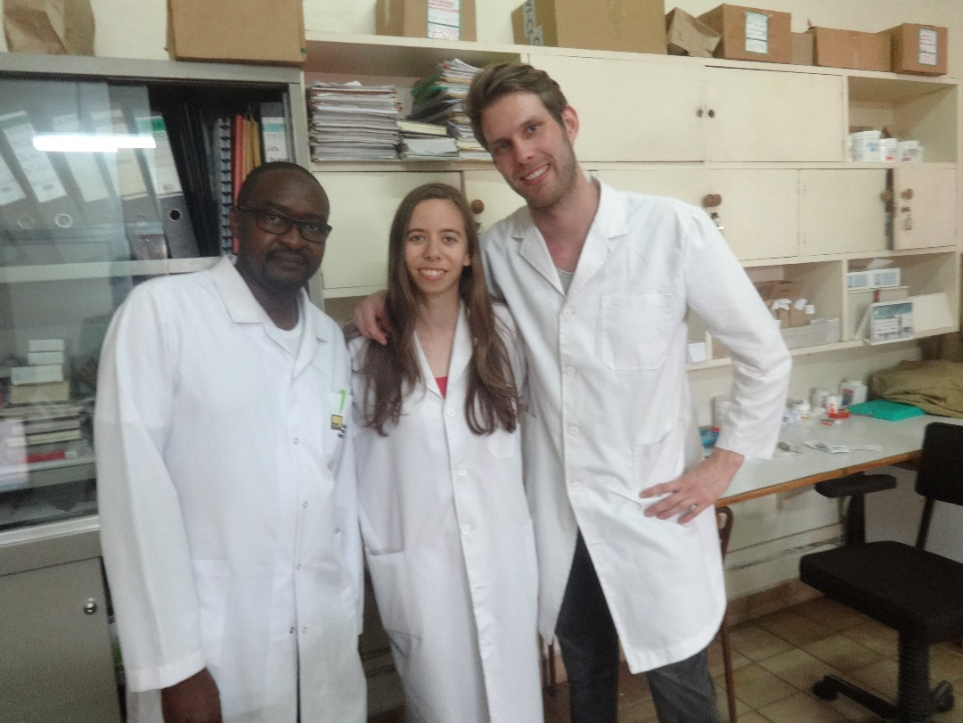
Though we couldn’t understand exactly what was discussed with patients because of the language, we did notice that the conversations were really short. It would be great to improve the information the patient gets about his/her medication (use and side effects), which could be done by an oral instruction by the assistant or pharmacist. It would also be a big improvement if the pharmacist could check for drug-drug interactions, though at this moment this is difficult because the pharmacy does not have medication overviews, there is no software available and it is told that most patients do not know what they are using. It might be an option to introduce paper cards on which is written which medication the patient is using and the patient should bring this along in every visit to a physician or pharmacist. The pharmacist is then able to use a free online drug interactions checker (Drugs.com, Medscape.com) to check for drug-drug interactions.

Pharmacist Richard Bugingo (in charge of the community pharmacy), Anke and me

Kibogora Hospital
Kibogora Hospital is a rural hospital on the shores of Lake Kivu in southwest Rwanda. It is also a referral hospital for the 12 most nearby health centers. The hospital has 269 beds and serves a population of approximately 250.000 Rwandans. It has a well-equipped laboratory, with HIV/Aids testing equipments and two pharmacies. In 2011 there were in total 12 doctors and 1 pharmacist.

We visited Kibogora Hospital for 3 days. For all employees the day started at 7.00 am in the church of the hospital and everybody started working at 7.45 am. Unless it rains heavily, then the day starts when the rain stops . Gaston is the pharmacist in charge and he took a lot of time to guide us.
There are two pharmacies within Kibogora Hospital, one for inpatients and one for outpatients. Outpatients first visit the doctor and then they have to pay for their medication at an administration desk before they can get their medication at the pharmacy. The pharmacist, Gaston, said this small pharmacy is part of the service they want to offer, as outpatients now only have to visit one of the building in the hospital. The second pharmacy is the inpatient one which is connected to the stock building. The pharmacy was not only responsible for the stock of medication but also for the stock of all medical devices. For all medication the stocks have to be recorded. There was also a small stock in the different wards available. It was a bit unorganized but for every patient there was a small box with his/her name on it and the medication in it. Beside that there were paper patient records in which was described which medication the patient has to use.
Patients, caregivers and nurses were able to get medication at the pharmacies with a prescription. The medication was dispensed by one assistant or pharmacist without any check. Every dispensed drug was written down in a book which was later processed in the national stock system. If possible, then medication was dispensed in a sachet on which it was possible to write the name of the patient, the drug and the dosage (symbols).
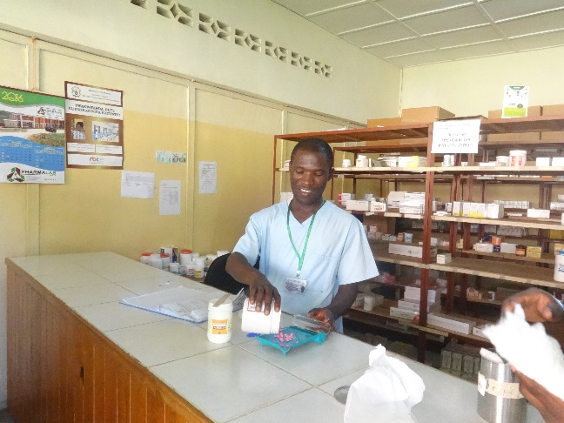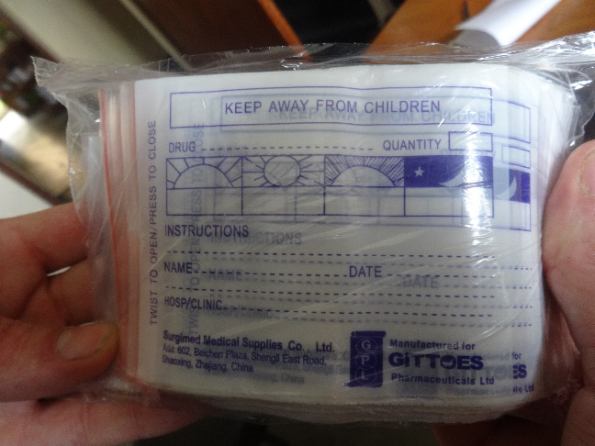
Left: pharmacist Gaston preparing medication. Right: dispensing sachets.
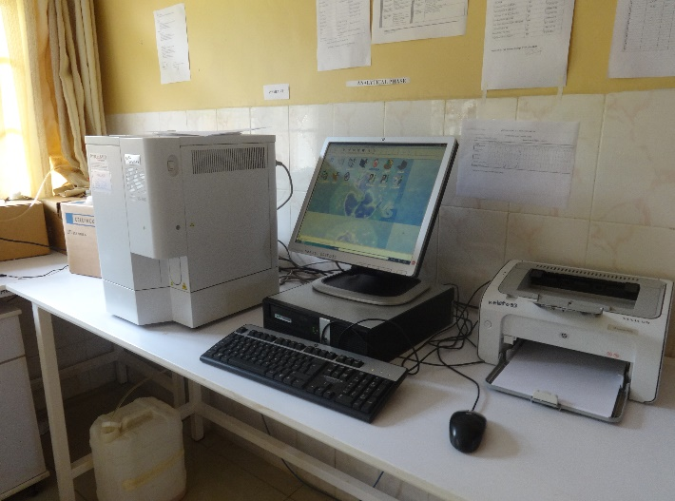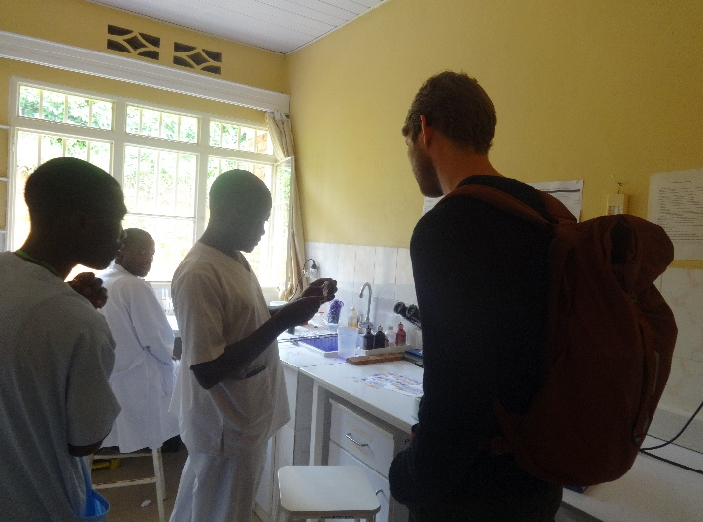In the hospital there was a well-equipped lab to do all standard blood tests and tests for malaria, HIV and tuberculosis. The hospital pharmacist is not involved in this laboratory except for his responsibility for the stocks.
Left: modern laboratory equipment. Right: checking for malaria using a microscope.
Recommendations
Like I already mentioned, no check is performed before dispensing medication. As in Rwanda no pharmacovigilance software is available I think there should be a focus on safety. An easy way to improve this safety is to include a check before dispensing the medication.
At this moment there are two pharmacies and in both there is just one assistant dispensing medication due to understaffing. Thereby it is difficult to maintain the stocks in the outpatient pharmacy, so sometimes they close it so the assistant can take some medication from the other pharmacy. Additionally, both pharmacies are less than a minute walk apart from each other.
Our idea was to close the outpatient pharmacy as long as the pharmacy is understaffed. If there would be only one pharmacy then the assistants are able to check (prescription, medication, use) each other before dispensing, what would increase the safety. During off-peak times it would be possible for one of them to do some other tasks. As it is only a short walk from the outpatient clinic we don’t think the closing will be a problem. We think it is more important to prioritize safety above service, especially in case of an understaffed department.

Pharmacy department at the University of Rwanda
The University of Rwanda was formed in 2013 through the merger of independent public institutions, the largest of which was the National University of Rwanda. The department of Pharmacy (under the Faculty of Medicine) is located in Huye (former: Butare). In 2008 an article in The New Times wrote about a shortage of pharmacists in Rwanda. Between 1982 and 2008 only 200 pharmacists graduated, but in 2008 100 pharmacy students were enrolled so the number of graduates will rise. After 5 years of study in the department students will graduate with a Masters in Pharmacy.

Part of the project is a visit to the pharmacy department of the University of Rwanda in cooperation with the Rwanda Pharmaceutical Students’ Association (RPSA). The first day we were welcomed by Elie Mandela, the former Public Health Officer of the RPSA. We got to know each other better while talking about the project, the differences between our studies and our future plans. He and another pharmacy student took us out for lunch to a good local restaurant. A big difference between our studies is the focus on stock managing (25% of their studies), which we don’t learn at all in the Netherlands.

In the afternoon he arranged that we were able to attend a lecture about Clinical Pharmacy, a course in the third year of their pharmacy studies. The ‘lecture culture’ was exactly the same as in the Netherlands: quite some students were late and most of them were playing on their phones during the lecture. It was a simple classroom but there was a computer and modern projector available, so the lecture was supported by a Powerpoint presentation. The only problem was that the electricity is not very stable, especially when it is raining. So several times the projector had to be started again, which took some time.

During the break some students came to us to ask a lot of questions. They were very interested in the project we were doing, comparing our studies and in student exchanges. It was really fun that those students were so enthusiastic. After the lecture unexpectedly one of the students took the floor to welcome us and asked us forward to present ourselves. We talked about the same subjects as during the break, but now with the whole class. I felt very welcomed this way!

The next morning student Elodea Manjohn showed us around at the university. We saw the hospital, library and labs. In the lab most of the equipment I used during my own studies were present, but of most there were just one or two devices. It was told that students do learn how to use those devices, but probably not as intensive as we do because they do not have enough equipment.

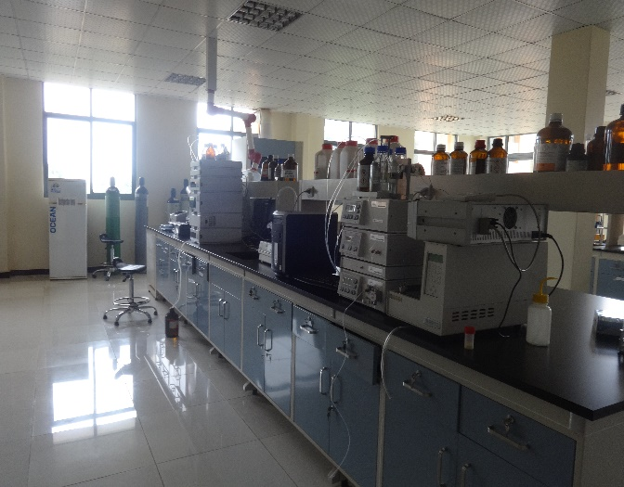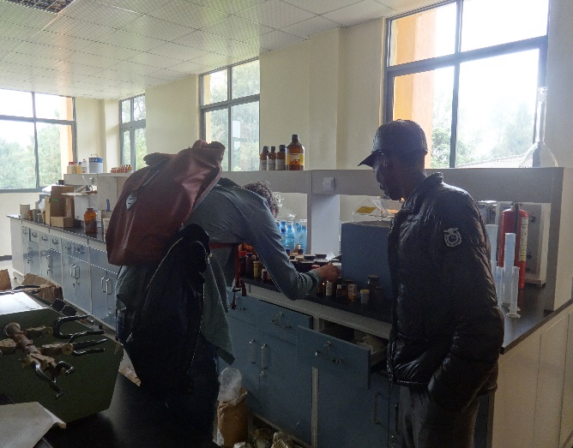Left: modern laboratory equipment. Right: me checking bottles with active substances with Elodea.

Another difference between our studies is the focus on pharmacognosy. In courses like ‘Botany – traditional medicine’ and ‘natural products & medicines’ all students learn which plants can be used in healthcare and how they can extract the active substances. Elodea Manjohn tried to show us the pharmacognosy laboratory, but unfortunately the person in charge was not available to give us permission.

Eric Bazericus showed us around at the University Campus. There are student’s apartments, a bar and several sports facilities.

Presentation
The last day we gave a presentation ourselves about community pharmacy practice and oncology practice in the Netherlands. We visited the university during the exam period, so most of the students were very busy, but luckily they wanted to join our presentation.

Based on our experiences the past weeks in Rwanda we wanted to show what processes are used in the Netherlands to improve medication safety. I presented this part of the presentation, showing the students the different steps in dispensing drugs. In each step I explained how we make the chance on any mistake as small as possible. An example was to implement a check by another assistant before dispensing a drug, an easy method to implement also in Rwanda.

In the second part of the presentation Anke talked about oncology practice, on request of some students as they do not learn a lot about this subject. She told them about the chemotherapeutics available in Rwanda, an example of an important drug-drug interaction, compounding chemotherapeutics, administering them and the responsibilities of pharmacists, doctors and nurses in the whole process.
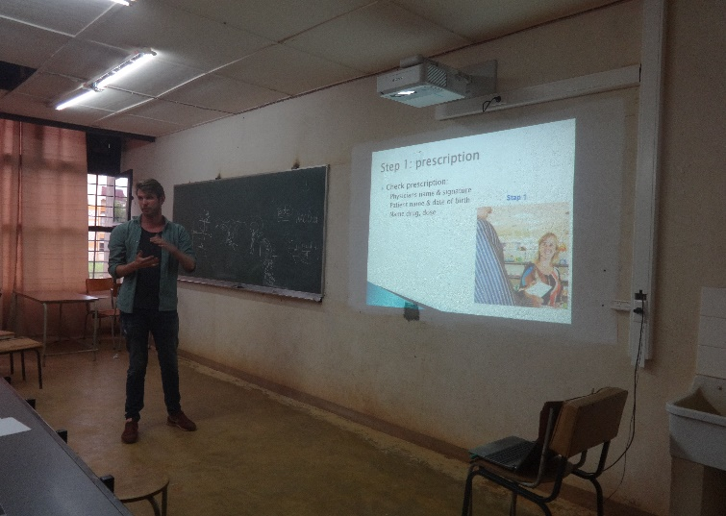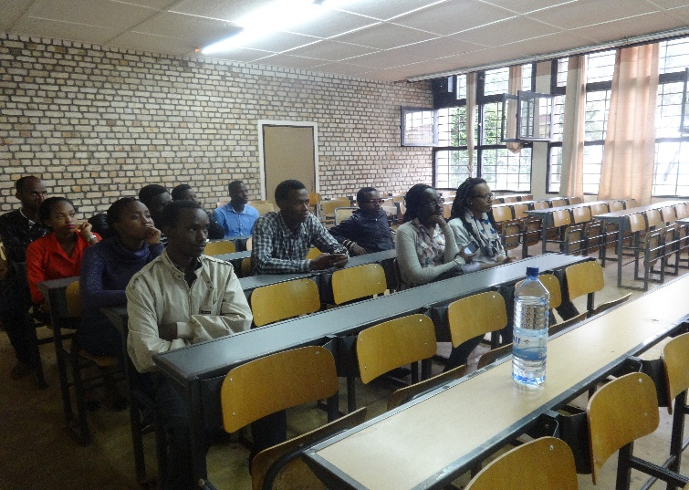The presentation was a nice way to interact with the students. They showed their interest by asking questions afterwards, concerning our presentation but also about pharmacy in general and personal questions.
Left: one of the classrooms at the faculty. Right: me presenting the presentation.
Recommendations
Concerning this visit I would like to recommend the next students to spend more time in Huye. We were only there for 3 days which was enough to see the whole university, but I think that getting to know the students is really interesting and could be really valuable for future FM projects in Rwanda. As I met passionate students it might be an idea to organize a brainstorm session during this week to find out what kind of projects FM could support now or in the future.

University Teaching Hospital Kigali
This hospital is one of four national referral hospitals. The other three are King Faisal Hospital in Kigali, University Teaching Hospital Huye and the Military Hospital in Kanombe. At the time I visited around 10 pharmacists were employed.
As we visited a district hospital, Kibogora Hospital, we thought it would be interesting to visit also a referral hospital. Via email we got in touch with the University Teaching Hospital in Kigali (CHUK) and the head of the pharmacy, Damaris Uwase, told us they would be happy to receive us.
The day we visited CHUK we were welcomed by John Nyiligira, pharmacist and also lecturer at the University of Rwanda. He showed us the pharmacy and told us about the hospital. The teaching hospital has about 10 pharmacy interns and one of them is Isreal Bimpe. He is the former president of the RPSA (2014-2015) and was in this function also involved in this FM project .
John Nyiligira involved us in the meeting with the pharmacy interns. He gave them an assignment in which they have to perform a medication review via a structured method, which surprised me in a very positive way. Pharmacy interns join the medical interns and physicians during their daily visits to the patients and are able to make an important contribution to treatments in this way. Then Israel was asked to guide us through the hospital.
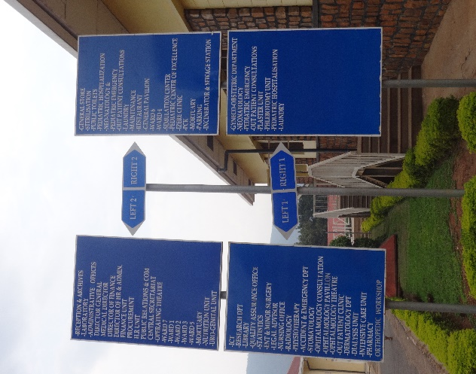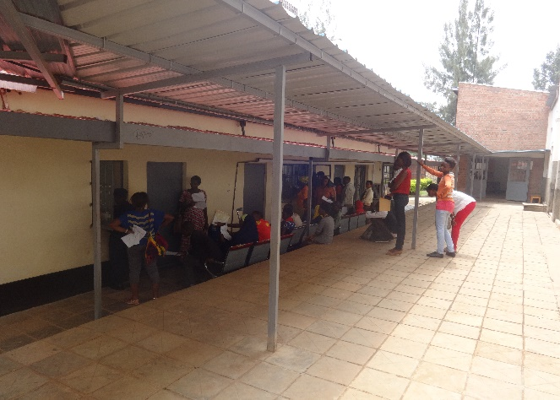CHUK has a specialized ward for HIV and AIDS patients. The patients visit the physicians regularly and receive medication for free, like everywhere in Rwanda. We were surprised by the fact that in a country like Rwanda, with its traumatic history, there are not many psychologists. Except for this HIV/AIDS clinic, where patients got offered psychological care, also to improve a better compliance of medical checks and medication use. Because we did not bring our white coats we unfortunately did not have the permission to go inside the wards.

Left: the pharmacy at CHUK. Right: a signposting for all different wards and departments.

Reflection
This project to Rwanda gave me the opportunity to further explore my interest in developmental work and working abroad. Three years ago I was searching for a volunteer project related to pharmacy. It was hard to find one, but I found an interesting project located in the slums of Manila, the Philippines. I planned and performed the follow-up of 80 children after they were treated by Dutch physicians. After this experience my interest was confirmed and ever since I was searching for a new opportunity.

Two years ago I read the advertisement for the FM student exchange project to Rwanda and there was no doubt about applying! It was great to hear that I was selected and finally after 1 year I was able to plan my trip together with Anke. I think it was a good idea to do this project together. As this project took place on several locations in Rwanda you travel quite a lot and you’re just for a relatively short time at each location. It is nice to have someone to exchange thoughts and ideas within a project and country like this. Thereby it was nice to travel together and have someone to wander through the streets and to visit the national parks.

During this project I realized that it can be complicated to support a pharmaceutical project with money and/or knowledge. Investing in projects you monitor from a distance requires good and reliable connections to manage the project on location. Also an essential aspect is a really good insight in the needs on the site and in the sustainability of projects you invest in. I think a project will only be successful by visiting the site regularly and keep in touch closely with the people leading the project on the site.

The project was great to experience Rwanda and also to see how pharmacy practice is done here. During the trip I met great, passionate, Rwandans working hard for their country. This experience stimulates me to search for a way to ensure that I will be able to do developmental work also after my graduation. In this way it would be great to stay involved with FM now and in the future!

Economic Development and Poverty Reduction Strategy, Government of Rwanda. 2013. http://edprs.rw/sites/default/files/docs/vision-2020.pdf
Wikipedia - Vision 2020 (Rwanda), last update: 20-08-2015. https://en.wikipedia.org/wiki/Vision_2020_(Rwanda). Retrieved at 1-07-2016.
Wikipedia - Rwanda, Health section. https://en.wikipedia.org/wiki/Rwanda#Health. Retrieved at 18-07-2016.
Millennium Development Goals Rwanda Final Progress Report: 2013. United Nations Development Program. http://www.rw.undp.org/content/rwanda/en/home/presscenter/articles/2015/03/31/millennium-development-goals-rwanda-final-progress-report-2013.html
Official website of Kibogora Hospital. http://www.kibogora.org/the-hospital/
The New Times. Official calls for more qualified pharmacists. 13-10-2008. http://www.newtimes.co.rw/section/article/2008-10-13/5377/

